Subject   
Key Specification  
Policy

Art and Design

Written by: Mrs. A Hurst and Mrs. P West

Date: September 2024

Review Date: Autumn Term 2025

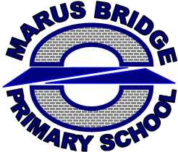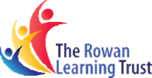

Contents

Rationale 2

Trust Level 2

School Level 2

Art Intent, Implementation and Impact 3

Art Intent 3

Art Implementation 3

Art Impact 4

National Curriculum Aims and Objectives 5

Stage Descriptors 6

Art Planning at Marus Bridge 8

Art Assessment at Marus Bridge 10

Resources: 11

Health and Safety 11

Safeguarding Considerations 12

Inclusion Considerations 13

Subject Monitoring: 15



# Rationale

## Trust Level

This document was created in conjunction with Art subject leads across the primary arm of the Rowan Learning Trust (RLT). Through this collaborative approach, ‘Stage Descriptors’ were identified and agreed upon on a trust level. These descriptors provide a list of objectives which each school uses as their baseline/non-negotiable objectives, providing a moderated approach to the content delivered in Art lessons across the RLT. Art leads across the Trust worked together to ensure that these Stage Descriptors met the National Curriculum Aims and Objectives.

## School Level

Using these Stage Descriptors, each school within the RLT has personalised their curriculum to suit their context and individual needs. Here at Marus Bridge Primary School, the Stage Descriptors act as a baseline to our ‘End Points Document’, which lists each objective to be taught within each individual topic. Topics and End Points have been selected with a great deal of purpose to reflect the intent of our curriculum at Marus Bridge and ensure that knowledge is sequential and interconnected.

# Art Intent, Implementation and Impact

## Art Intent

We aim develop children’s artistic knowledge and skills to provide them with the tools they need to express themselves creatively – viewing themselves as the developing artists they are. Through the course of their studies, our pupils encounter a range of diverse artists/architects/designers across different mediums to develop deepening and progressive understanding of 3 key concepts: drawing, painting and sculpture. We aim to develop children’s understanding of artists and their styles, allowing them to engage in practical artwork within these traditions. Children are given the subject knowledge they need to engage in artistic exploration and appraise their own work along with the work of others. Our pupils have lots of opportunities to work towards creating an end-piece which is celebrated and displayed around school and the local community (such as within the WOWs festival).

## Art Implementation

Our curriculum (developed by our teachers and the subject lead) is based on theoretical knowledge leading to the application of skills and practical work. We offer a ‘depth over breadth’ approach to curriculum planning, focusing primarily on the 3 concepts above. Each year group completes 3 topics a year (one for each concept) which offers a spiral approach to the curriculum and ensures that children’s learning is based on what’s been taught previously and adds to their existing theoretical knowledge and practical skills. Art is taught by class teachers for a minimum of 60 mins per week in every classroom (although this is delivered more holistically in EY and Y1). All planning for art has been created by class teachers, supported by the subject and curriculum lead.

To support the acquisition of artistic vocabulary, tier 2 vocabulary has been carefully selected by the subject lead, and vocabulary reoccurs through the curriculum to support overlearning (See End Points document for **colour coding of vocabulary**). Across school, children are taught how to use sketch books to note their ideas and practise key practical skills. Children will also use sketch books to note theoretical knowledge to assist retention. The framework below is implemented in each Art topic across the school (Y1-6) to support sticky learning.

In addition to our topic structure, teachers also plan lessons which follow our lesson structure below:

Our MB10 (see separate document) is also used across the breadth of the curriculum to ensure that cognitive learning strategies are used as a pedagogical tool to support effective teaching and learning.

## Art Impact

Our pupils love art! Pupil interviews and classroom observations show great enthusiasm towards the subject from children and staff alike. Supported by build-up work in their sketch books, children create impressive and uniquely different pieces of artwork, demonstrating their individual creativity.

In terms of data, at the end of the 23-24 academic year, 86.1% of children reached the expected standards in Art. As a trust, our moderation process concluded that 80% is the average across the Trust.

# National Curriculum Aims and Objectives

|  |  |
| --- | --- |
| **National Curriculum Objectives** | |
| **KS1** | Pupils should be taught:   * to use a range of materials creatively to design and make products * to use drawing, painting and sculpture to develop and share their ideas, experiences and imagination * to develop a wide range of art and design techniques in using colour, pattern, texture, line, shape, form and space * about the work of a range of artists, craft makers and designers, describing the differences and similarities between different practices and disciplines, and making links to their own work. |
| **KS2** | Pupils should be taught to develop their techniques, including their control and their use of materials, with creativity, experimentation and an increasing awareness of different kinds of art, craft and design. Pupils should be taught:   * to create sketch books to record their observations and use them to review and revisit ideas * to improve their mastery of art and design techniques, including drawing, painting and sculpture with a range of materials [for example, pencil, charcoal, paint, clay] * about great artists, architects and designers in history |

# Stage Descriptors

|  |  |
| --- | --- |
| **Stage Descriptors (agreed upon on a Trust level)** | |
| **EYFS** | * Appropriately choose, use and begin to control a range of media safely * Talk about what they have produced * Develop skills in manipulating malleable materials |
| **KS1** | Sketchbooks:  - Use a sketchbook effectively to gather ideas  Artists:  - Have knowledge of and appraise a diverse range of artists through history  Drawing:  - Use a range of dry media to explore the elements of art: line, colour and shape.  Painting:  - Demonstrate knowledge about primary and secondary colours  - Use, and be able to name, a variety of paint, paper and implements to create  Sculpture:  - Plan and create sculptures and constructions  - Develop skills in manipulating clay: rolling, kneading and shaping  Other art:  - Create art supported by photography, digital art, pattern, printmaking or texture and collage |
| **LKS2** | Sketchbooks:  - Use a sketchbook effectively to gather and build ideas  Artists:  - Have knowledge of and appraise a diverse range of artists, architects and  designers through history  Drawing:  - Use a range of dry media to explore the elements of art: line, tone, pattern, texture, colour and shape.  Painting:  - Demonstrate a knowledge about primary and secondary colours, making and matching colours  - Choose appropriate, paint, paper and implements to create  Sculpture:  - Plan and create sculptures and constructions with reasonable independence  - Develop skills in joining and modelling clay  Other art:  - Create art supported by photography, digital art, pattern, printmaking or texture and collage |
| **UKS2** | Sketchbooks:  - Use a sketchbook effectively to gather, build ideas and evaluate  Artists:  - Have knowledge of, appraise and take influence from a diverse range of artists, architects, and designers through history, including those from the local area  Drawing:  - Proficiently manipulate and show improved mastery of, using dry and wet media, the elements of art: line, tone, pattern, texture, form, space, colour and shape.  Painting:  - Demonstrate a secure knowledge about primary and secondary, warm and cold, complementary and contrasting colour, making and matching colours  - Choose appropriate, paint, paper and implements to create, adapt and improve  Sculpture:  - Plan and create a sophisticated sculpture or construction with increasing independence  - Develop skills in using clay, including slabs, coils, slips etc.  Other art:  - Create art supported by photography, digital art, pattern, printmaking or texture and collage |

# Art Planning at Marus Bridge

**Long Term Plans**

Each year group provides LTPs which give an overview of the learning/topics which will take place over the course of the year. These are shared with parents on our website.

**Medium Term Plans**

MTPs are completed by class teachers every half term. The MTP maps out the sequence of objectives to be taught within the art topic for that half term. MTPs list the lesson objectives (presented as a WALT to the children) and documents the basic overview of the lessons. Weekly plans, PowerPoints and lesson resources are then saved in the staff Shared Area and audited by the subject and curriculum lead annually.

**Scheme of Work**

The following topics/scheme of work is followed here at Marus Bridge. All planning for these topics has been developed internally without the use of an external scheme. This is to ensure that our curriculum is bespoke to our pupils, staff and context. The progressive objectives for each topic can be found within the Art End Point Document.

|  |  |  |  |
| --- | --- | --- | --- |
|  | Drawing | Painting | Sculpture |
| EYFS | Self Portraits  Artist: none  Theoretical and skill practise: explore using different media to draw | Splatter Monsters  Artist: Jason Pollock  Theoretical and skill practise: splattering and blowing paint, understand what the primary colours are | TBC |
| Y1 | Making Waves - Blending  Artist: Helen Oxenbury  Theoretical and skill practise: blending is easier with some media, understanding of cool colours | Mixing it Up!  Artist: Paul Klee  Theoretical and skill practise: knowing primary colours, making secondary colours and using a variety of brush sizes | TBC |
| Y2 | At the Farm - Cross-Hatching  Artist: John Burningham/Helen Oxenbury (review of Y1)  Theoretical and skill practise: cross-hatching/hatching and using different gradients of pencil and choosing a preference | Sunflowers  Artist: Vincent Van Gough  Theoretical and skill practise: making colour lighter and darker with different methods: using black, using white, using water, understanding of warm colours | TBC |
| Y3 | Creating Characters  Artist: Quentin Blake  Theoretical and skill practise: proportion and shading using coloured pencils (using blending, stippling, cross-hatching) | Watercolour Florals  Artist: Rose Ann Hayes  Theoretical and skill practise: making primary, secondary and tertiary colours using watercolour | TBC |
| Y4 | Focusing on Features – Stippling  Artist: David Accurso  Theoretical and skill practise: stippling and shape/lines | Abstract Acrylics  Artist: Georgia O’Keefe  Theoretical and skill practise: blending acrylic paint and creating a background wash | TBC |
| Y5 | Proportion through Portraits  Artist: Frida Kahlo  Theoretical and skill practise: how to sketch, proportion | Impressionism and the Industrial Revolution  Artist: James Isherwood  Theoretical and skill practise: impressionist painting to create texture, using small and thin brush strokes | TBC |
| Y6 | Picture Perfect  Artist: Edward Weston  Theoretical and skill practise: taking macro photographs then using blending, stippling, hatching, cross-hatching to copy these photos using proportion and obscuration | Pebble Paintings  Artist: a variety of landscape artists, including a review of ones already studied  Theoretical and skill practise: knowledge review of blending, colour mixing, choice of paint brush, darkening and lightening paint, expressing themselves in their own unique style | TBC |

# Art Assessment at Marus Bridge

In Reception, children are assessed against the Early Learning Goals for 'Expressive Arts and Design. For children in Years 1 - 6, children are summatively assessed in Art at the end of each academic year on Arbour (our internal assessment system). These assessments are based on children’s engagement, retention and articulation of the ‘End Point’ objectives for their year group. To inform these assessments, class teachers keep a log of children’s achievement in each topic in their ‘formative assessment’ booklets, along with any notes to support their judgements.

The following assessment strategies support teacher observation and data collection:

* Informal quizzes
* Classroom questioning
* Reviewing art work
* Daily Review analysis
* Questionnaires
* Self and peer assessments
* Presentations
* Speaking and listening activities
* Prior learning activities
* Knowledge Review Week activities
* End of unit formative assessments (completed a few weeks after the topic has finished)

At the end of each academic year, each child is assigned one of the following gradings on Arbour:

|  |  |
| --- | --- |
| **PKS** (Pre-Key Stage) | Children have not been exposed to the full curriculum due to a significant SEND. |
| **HNM** (Has Not Met) | Children can’t articulate answers to the majority of the questions listed in the End Point document for this subject. |
| **EXS** (Expected) | Children can articulate answers to the majority of the questions listed in the End Point document for this subject. |
| **Gifted and Talented** | Children show a specific talent for an aspect of the subject. |

# Resources:

The following resources are available to support the delivery of the Art curriculum at Marus Bridge:

* Knowledge Organisers for each topic (developed in-house to reflect our bespoke curriculum)
* Topic planning resources (Collated in the planning folder)
* Topic-specific non-fiction books (stored in the school library)
* Library loan books (based on a specific topic) can be hired from Marsh Green Library free of charge.
* Educational visits are planned to enhance learning and provide exposure to professional artwork.
* Art supplies are stored in a central art area within school.  Most teachers also have a small supply of frequently used tools and materials in their own classrooms.  Basic art supplies are restocked for the beginning of each academic year. More specialist supplies should be requested separately. As materials are used up, empty containers should be disposed of and not placed back in the resource area.  The art co-ordinator should be advised which material has been used up and needs replacing.  (the maintenance of this area is the responsibility of all staff and children where appropriate.)
* Every child should be equipped with a sketch book that contains cartridge paper.  Children work directly into sketch books as much as possible.  Sketch books that are incomplete at the end of the school year should be continued in the next year until they are full.

# Health and Safety

Ensure appropriate risk assessments have taken place when planning external visits (see school policy guidelines). In school, be aware of:

* The use of toxic materials
* Students washing their hands correctly after working with materials
* Allowing eating and drinking whilst using materials
* Keeping the sink area clean and tidy at all times and water spills to be cleaned up immediately to prevent slipping on the wet floor.  Exercise caution when allowing children access to the art area, including to clean up
* Allowing adequate fresh air by opening windows
* Electric tools to be in good working order
* Watch for exposed cuts on children’s hands
* Providing cover-ups for messy work, and avoid loose fitting clothing and dangly jewellery. Hair to be tied back
* Teachers should not fire a kiln or mix dry materials when students are in the classroom
* Children should be supervised if asked to help wash art equipment in the art area

# Safeguarding Considerations

Any external providers must provide evidence in the office of the Enhanced DBS before being left alone with pupils. They must also be reminded of the importance of not using mobile phones within the school.

# Inclusion Considerations

The class teacher meets the needs of the most able and SEN by differentiating Art lessons through levels of support provided and adopting a mastery approach. Children identified as having additional Special Educational Needs may need greater differentiation of materials and tasks consistent with that child’s I.E.P. (Individual Education Plan). More able children will be challenged and motivated by greater differentiation of challenge. The class teacher also aims to identify those children who may be gifted in Art and provide them with appropriate learning opportunities. All children will be given opportunities to participate on equal terms in all Art activities and due consideration will be given to the principles of inclusion.

As a school, we use our ‘SEND Toolkit for the Wider Curriculum’ to ensure every child’s needs are met in Art:

Non-Negotiable Adaptions   
(should be considered in **EVERY** lesson):

1. **Reduce** the amount of knowledge to be learnt (3-4 pieces maximum)
2. **Concentrate on the content**, not the task
3. Link to **prior-knowledge**
4. **Limit admin tasks** (avoid spending too much time on admin which may hinder cognitive load – such as cutting out or writing long WALTs)
5. **Model activities** (I do – we do- you do)
6. **Consider IEPs/EHCPs** (Ie – consider how a hands-on activity might affect those with sensory needs and adapt appropriately. Consider whether buff printing will be helpful)

Possible Adaptions  
(Select where appropriate for each subject/lesson):

|  |  |  |  |
| --- | --- | --- | --- |
| **Visual Aids**  Provide images to explain vocab/concepts rather than wordy definitions | **Key Vocabulary Banks**  Using vocab from the End Points, reduce the number and send some key vocab home, or rehearse in school. | **Continuous Provision**  Provide an alternative hands-on activity for the children to access. | **Pre-Teaching**  Could a member of staff/a volunteer give some input before the lesson? |
| **Mixed Ability Groups/Pairs**  Try to limit group size to 3 children to ensure that all children are actively involved. Give SEND children a specific role within the group. | **Print Longer WALTS**  Depending on individual needs, this may help some SEND children to reduce cognitive load. | **Adapted Knowledge Organiser**  Reduce the vocabulary and provide visuals. | **Differentiated Texts**  If using texts/books as the source of information, differentiate the text/book. Use online sources for this for workload |
| **Provide Additional Adult Support** | **Provide Additional Brain Breaks** | **Simplified Recording Methods**  Such as a reduced table in science, or a partially completed bar chart | **Differentiated Research Sources** |
| **Consider Timings of** **Interventions**  Ensure that children do not miss a whole unit/input for intervention. | **Reduce Distractions**  (In a lesson such as music, would excess noise prevent children from engaging? Could they complete the lesson in a quieter spot?) | **Adapt the Apparatus**  Eg – provide larger equipment in PE etc… | **Individual Interests**  Tap into individual interests to help represent information. Eg – a child who loves drawing might make a picture to represent what they’ve learnt in Art |

# Subject Monitoring:

The Art coordinator will complete one audit within each academic year to assess children's understanding and monitor teaching against the National Curriculum and End Point Objectives. This will focus on sampling children's work/sketchbooks, child interviews and lesson drop ins/observations.

Art is audited in the autumn term each year, and an action plan for the following 12-month period is devised in response to the audit.

In the spring and summer terms, the Art lead will be given time (up to a full day each term if needed) to implement actions to support their action plan targets and provide support when needed. Support will be offered to any year groups who require additional information and guidance. This may be done by: discussing assessment methods; modelling lessons; inviting teaching staff to observe the Art coordinator; providing training or observing lessons and providing constructive feedback.

Governors are to be provided with an update each term in relation to the subject development. The Governor currently assigned to Art at Marus Bridge is Mrs Pitts.

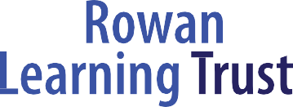

Our logo was carefully chosen to represent the children, young people and adults in our learning community who strive for excellence through high aspiration and high expectation.

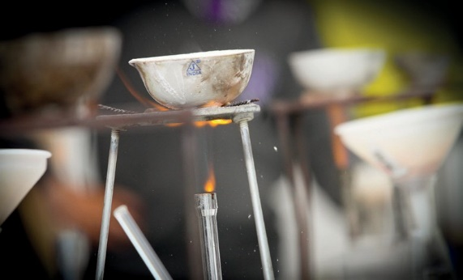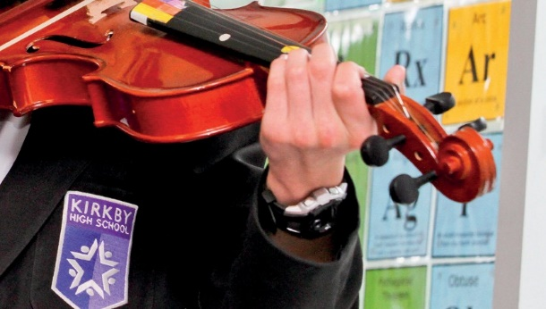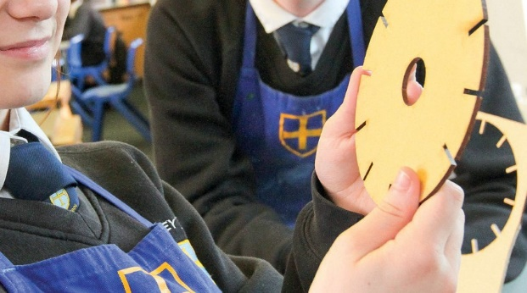

The Rowan Learning Trust

Registered Office: Hawkley Hall High School, Carr Lane,Wigan,WN3 5NY. Company Number 8010464

© The Rowan Learning Trust 2018