WOWS
With Others We Succeed

Special Educational Needs and Disabilities Booklet (SEND) for parents and carers

WOWS is a group of Wigan Primary Schools and one Special School who work collaboratively to improve opportunities and standards across all the schools and across the broad spectrum of the National Curriculum. Working collaboratively across the network underpins the value of WOWS and offers a supporting learning environment for professionals and outcomes for children. As part of the WOWS inclusion agenda, a shared commitment to Special Educational Needs and Disability remains at the forefront of our practice.
Involved in the production of this Parent Information Booklet for SEND was a collection of Special Educational Needs and Disability Leaders (SENDCO) from schools within the WOWS group. The booklet is intended to be used as a guide for parents as a tool to help them to navigate the SEND processes in Wigan. The content reflects a collaboration from school leaders within the WOWS group.
Special accreditation must go to specific SENDCOs:
Leanne Bannister | Vicky Heyes |  | Georgia Young
Kathryn Parkinson | Georgia Evans |  | Rachel Penman
Karen Kissack | Jackie Lloyd |  | Shona Formby
Julie Hayes | Cath McGrath |  | Rebecca Holland
Gemma Gaskell | Beverley Morgan |  | Rachel Cregan
Wendy Morris |  | Dominique Mottram

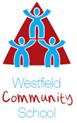
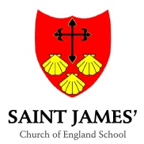
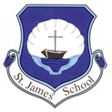

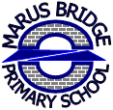
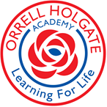

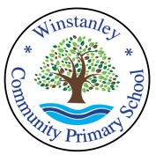

Special Educational Needs and Disabilities Booklet (SEND) for parents and carers

Contents
Page 4
Introduction
Page 5
The Graduated Approach
Page 6
Applying for an Education Health Care needs assessment.
Page 7
Support services available
Page 8
Areas of Need
- Cognition and Learning
- Communication and Interaction
- Physical and Sensory
- Social, Emotional and Mental Health (SEMH)
Page 9
What can you do as parents to support your child’s education?
Page 10
Working together

Introduction
This booklet is to provide families with information to understand the processes schools may use to support children with additional needs. This SEND information has been written collaboratively across a local network of Wigan schools (WOWS) with a shared commitment to special educational needs and disability.
The information included within this booklet is to support families as first educators of their children. Professionals across all schools strive to work in partnership with families to ensure that all children thrive to achieve their potential through enjoyment, engagement and the removal of barriers to learning such as emotional stress, learning difficulties and/or low school attendance.
The intention of this booklet is to clearly outline some of the procedures, pathways and language involved in your child’s SEND journey – this is often referred to as the graduated approach. Every Local Authority has a legal responsibility to publish their local offer for SEND which explains the graduated approach in detail. Wigan’s local offer can be found here: www.wigan.gov.uk/sendlocaloffer

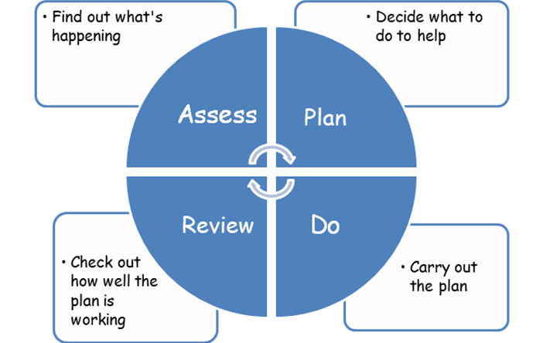
All schools work with a continuous cycle when identifying and addressing children’s needs.

The Graduated Approach

The graduated approach will be followed by all schools and underpins the approaches to inclusion across all settings. Primary schools liaise closely with high schools to ensure a successful transition and continuity of support for children. All aspects of SEND require schools to follow a process based on an assessment of need and intervention over time so that information and evidence can be gathered.

All learners will access inclusive teaching which takes into account individual learning needs. This is known as the universal offer. Most children’s needs will be met through the universal offer. The curriculum is adapted for all children regardless of a child having an identified SEND need.

Some learners need additional support which can be provided by the school using their own resources:

- Class provision
- Opportunities to overlearn
- Pre-teaching
- Adapted teaching including use of additional resources
- Intervention activities within the classroom environment and/or withdrawn as part of a small group/or 1-1 specific intervention

A few learners need further support and school will often seek advice and guidance from other support services. This is a process over time (time lengths are dependent upon the child’s specific need or the specialised support required) and involves the recommendations of a range of professionals alongside family views.

In a small minority of cases a child may have such severe and complex needs the school might need to request additional resources. This could result in the Local Authority initiating an EHC (Education, Health and Care) needs assessment.

An EHC needs assessment will not always lead to an EHC plan. The information gathered during an EHC needs assessment may indicate ways in which the school, college or other provider can meet the child or young person’s needs without an EHC plan. It is important to acknowledge that a diagnosis of a medical condition or a learning need does not automatically mean that a child meets the criteria for an EHC plan.

Applying for an Education Health Care needs assessment

The Department for Education clearly states that a range of people can ask the Local Authority to conduct and EHC needs assessment in the SEN code of practice:

‘The following people have a specific right to ask a local authority to conduct an education, health and care needs assessment for a child or young person aged between 0 and 25:

- the child’s parent
- a young person over the age of 16 but under the age of 25, and
- a person acting on behalf of a school or post-16 institution (this should ideally be with the knowledge and agreement of the parent or young person
where possible)

Anyone else can bring a child or young person who has (or may have) SEN to the attention of the Local Authority, particularly where they think an EHC needs assessment may be necessary. This could include, for example, foster carers, health and social care professionals, early years practitioners, youth offending teams or probation services, those responsible for education in custody, school or college staff or a family friend. Bringing a child or young person to the attention of the Local Authority will be undertaken on an individual basis where there are specific concerns. This should be done with the knowledge and, where possible, agreement of the child’s parent or the young person’

DFE and department of health (SEN Code of practice) 2015

Support services available
There are a range of support services that can be accessed by parents/carers and/or schools. Further information can be found on the local offer -
www.wigan.gov.uk/sendlocaloffer
Listed below are examples of some support services available to schools and is not an exhaustive list.
Educational Services
Early Learning and Child Care Team (Nursery & Reception)
Targeted Education Support Service (TESS)
Ethnic Minority & Traveller Achievement Service (EMTAS)
Educational Psychology (EP)
Schools Outreach Service - to support inclusion in mainstream

Health Services can be found via:
https://www.wigan.gov.uk/Resident/Education/Special-Educational-Needs-and-Disability/Local-Offer/Parent/Health/Health-services/Index.aspx
Occupational Therapy (OT)
Speech and Language Therapy (SALT)
Physiotherapy
Child and Adolescent Mental Health Service / School Link Service (CAMHS)
School Nurses
Specialist Sensory Education Team (for hearing and vision impairments)

Early Intervention and Social Care Services:
Startwell
https://www.wigan.gov.uk/Resident/Health-Social-Care/index.aspx

Voluntary Organisations:
Wigan Family Welfare
https://familywelfare.co.uk/
Wigan and Leigh Embrace https://www.embracewiganandleigh.org.uk/

Areas of need

Cognition and Learning

All children learn at different paces. Children may be identified as having a cognition and learning need if they have difficulties with the key skills within literacy and/or numeracy (which may then impact on a child’s ability to access other areas of the curriculum) or if attainment is significantly below age related expectations (ARE). Support for learning needs may be required when concerns are raised by professionals regarding the progress of learning of children and young people, even with appropriate adaptations.

Communication and Interaction

Children and young people with speech, language and communication needs (SLCN) have difficulty in communicating with others. This may be because they have difficulty saying what they want to, understanding what is being said to them or they do not understand or use social rules of communication. Every child with SLCN is different and their needs may change over time.

Physical and Sensory

Some children and young people require special educational provision because they have a disability which prevents or hinders them from making use of the educational facilities generally provided. These difficulties can be age related and may fluctuate over time. Many children and young people with vision impairment (VI), hearing impairment (HI) or a multi-sensory impairment (MSI) will require specialist support and/or equipment to access their learning. Reasonable adjustments will always be made to accommodate a child with a physical disability.

Social, emotional and mental health (SEMH)

Children and young people may experience a wide range of social and emotional difficulties which manifest themselves in many ways. These may include becoming withdrawn or isolated, as well as displaying challenging, disruptive or distressing behaviour. These behaviours may reflect underlying mental health difficulties such as anxiety or depression, self-harming, substance misuse, eating disorders or physical symptoms that are medically unexplained. Other children and young people may have disorders such as attention deficit disorder (ADD), attention deficit hyperactive disorder (ADHD) or attachment disorder.

What can you do as parents to support your child’s education?
Attendance
Children’s learning is significantly impacted by attendance. Most children learn better in a productive learning environment with their peers and with a trained professional delivering exciting, engaging and appropriate material. It is parental responsibility to ensure maximum attendance for their child. Support services involved with your child will take into account attendance and punctuality. Children’s progress will be affected if they are not in school to access education.

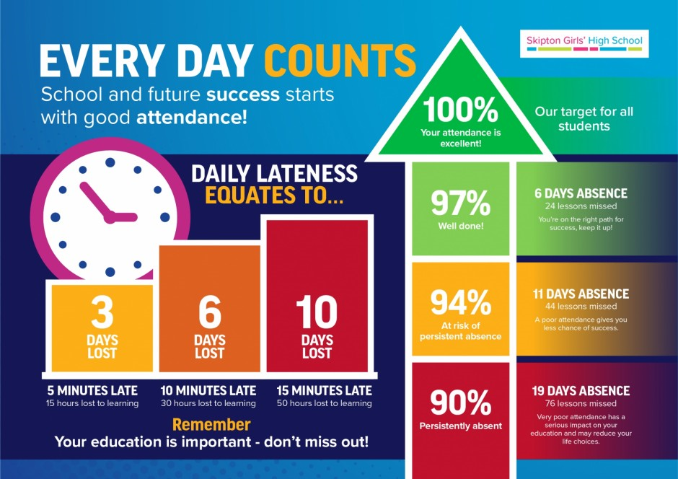

Attend appointments
If your child is accessing specialised support services please ensure you attend these very important appointments and keep school informed with regards to updates and outcomes.
Home activities
As a team we want your child to achieve their best. Please follow recommendations from specialised services and education providers to help your child to make progress.

Working together

Children achieve better when a productive home-school relationship is nurtured. Children love to see their teacher parent/carer having a good working relationship. It is important that we work together to understand your child’s individual needs and how they may present in different settings. This understanding will help your child to flourish and achieve in line with their potential on their learning journey.

The WOWS network is dedicated to providing the best education possible for all our children. We are committed to following the guidelines and statutory processes within this booklet.

We hope you find the information within this booklet useful and it supports you as first educators of your child.

