Marus Bridge Primary School

EYFS Curriculum 2021 and National Curriculum Links

Art & D.T
Links for Art & D.T are found mainly in Expressive Arts & Design and Understanding the World
Reception  Explore, use and refine a variety of artistic effects to express their ideas and feelings.  Return to and build on their previous learning, refining ideas and developing their ability to represent them.  Create collaboratively, sharing ideas, resources and skills.  End of EY Expectations – ELG for EAD  Creating with Materials  Safely use and explore a variety of materials, tools and techniques, experimenting with colour, design, texture, form and function.  Share their creations, explaining the process they have used.  Make use of props and materials when role playing characters in narratives and stories. | Links to our curriculum and literature spine:  Text: The Everywhere Bear  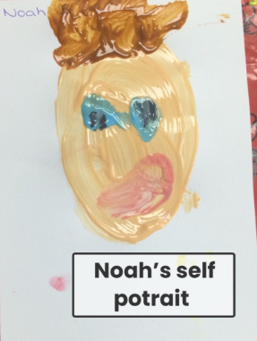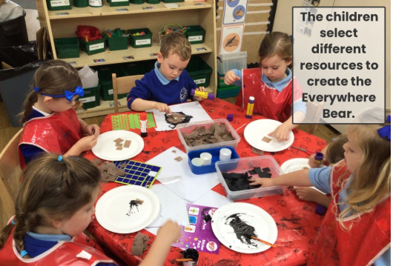  Self portraits focusing on use of painting.  To describe texture: smooth, rough etc.  Children to make bear collage Vocab: texture.  Drawing Know how to use pencils, chalk, charcoal to make zig zag, straight lines, curved lines and wavy lines.  Vocab: straight, curved, wavy, zig zag  Mark Making_ Printing- Know that objects can be used to make marks.  Text: The Avocado Baby  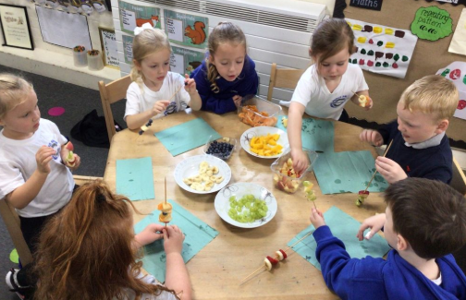  Safely use and explore a variety of tools. Food – Make fruit kebabs.  Text: The Colour Monster  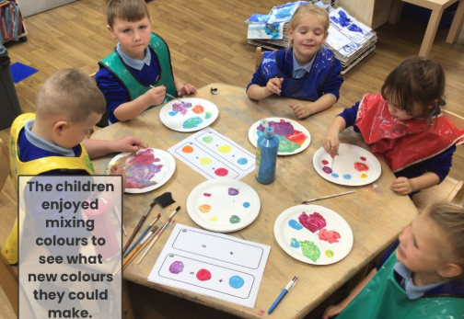  Colour Naming colours, how to mix colours Colour mixing begin by naming primary colours – yellow, red, blue then.  Text: The Room on the Broom  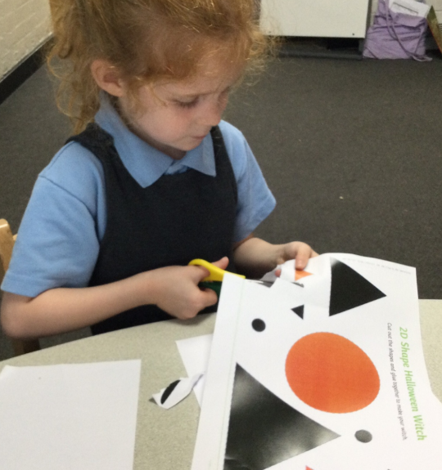  Safely use and explore a variety of tools including scissors.  Text: T Hovis the Hedgehog  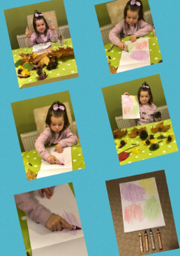  Rubbings Print with variety of Objects including leaves.  Text: Emily Brown and the Thing  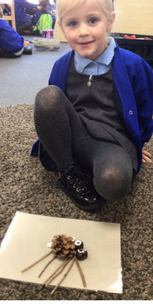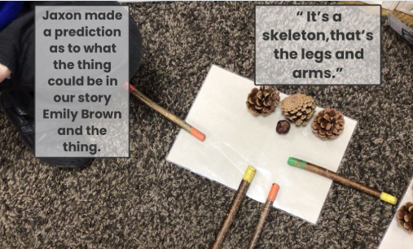  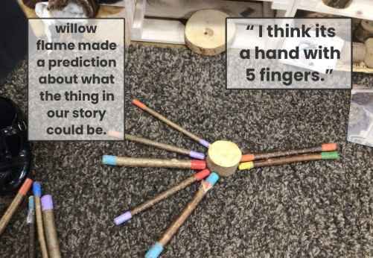  Transient Art related to seasonal changes. Activities-Children create own thing using natural items.  Text: The Queen’s Present  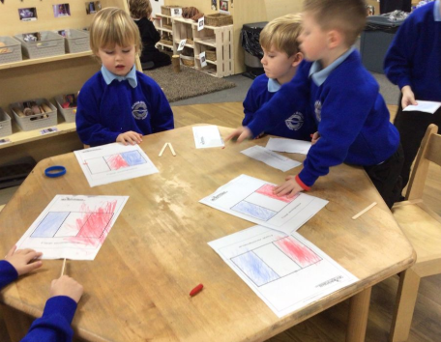  Mark Making Colour flags from countries of the word.  Text: Astro Girl  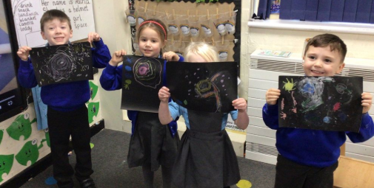  Drawing Know how to use pencils, chalk, pastels to make zig zag, straight lines, curved lines and wavy lines. Vocab: straight, curved, wavy, zig zag Investigate different lines.  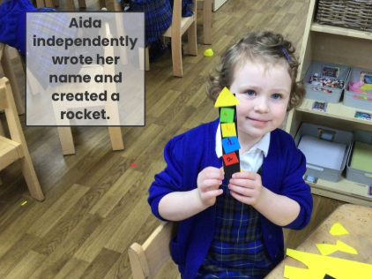  Form-Art related to space. Building rockets.  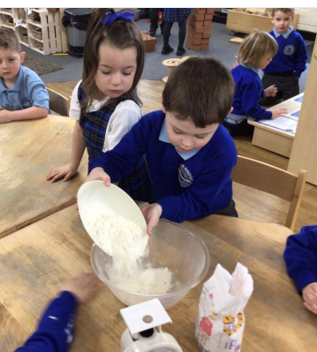  Safely use and explore a variety of tools. Food – Make vanilla biscuits.  Text: The Great Race  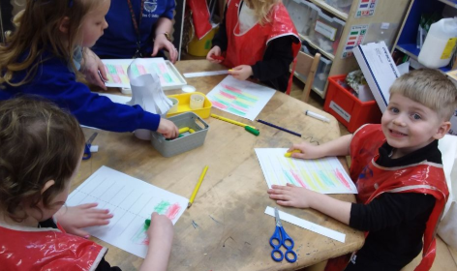  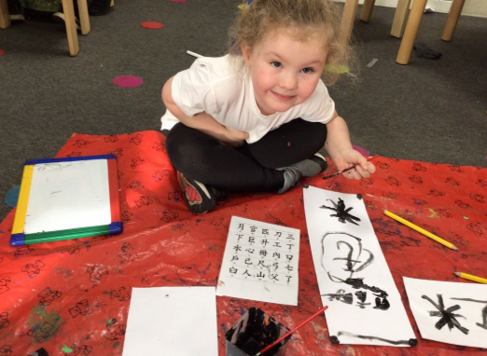  Activities Chinese New Year, explore through ,art work, stories and role play. Children write their name in Chinese and make lanterns.  Text: Somebody Swallowed Stanley  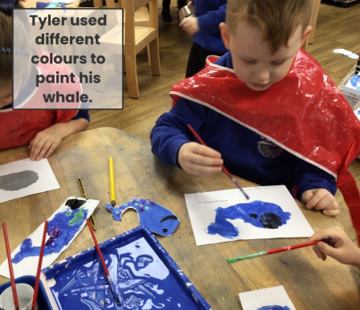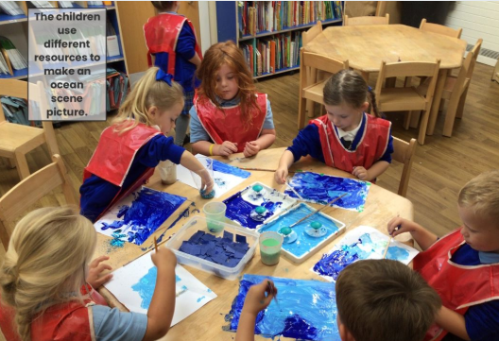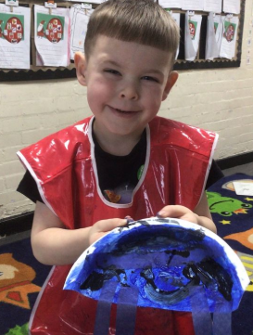  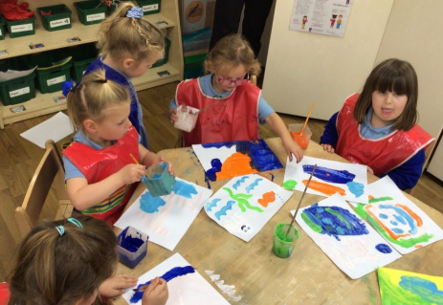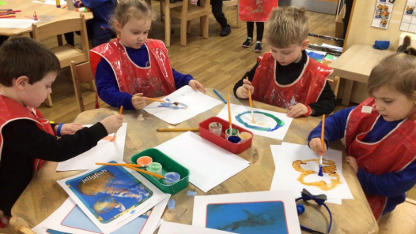  Created an under the sea picture. Made paper plate Jellyfish.  Text: Jack and the Flum Flum Tree  Colouring mixing using coloured water.  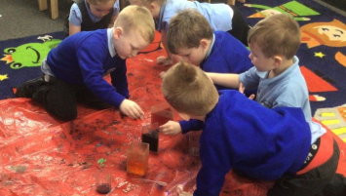  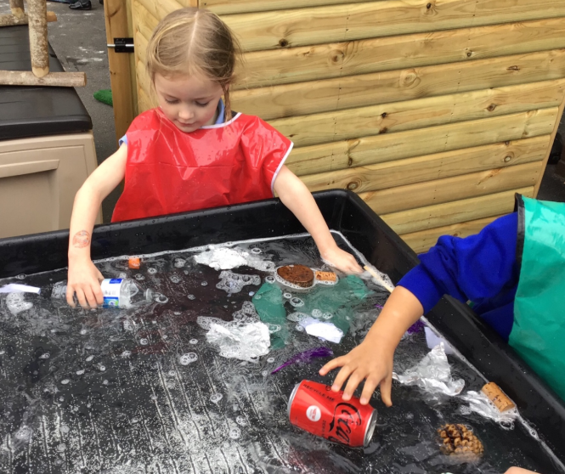  Design Tech Focus -Structures Design own water based vessel based on children’s interests and explore the features of what makes a good water vessel. Children explore floating and sinking (UTW science) use their knowledge to design and build their own vessel: submarine, boat, hovercraft.  Draw and paint a shark.  Bonfire Night  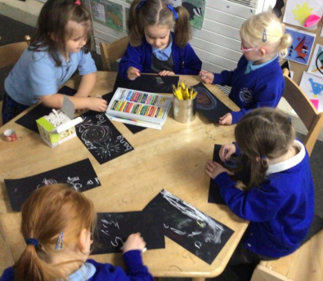  Drawing Know how to use pencils, chalk, pastels to make zig zag, straight lines, curved lines and wavy lines. Vocab: straight, curved, wavy, zig zag Investigate different lines.  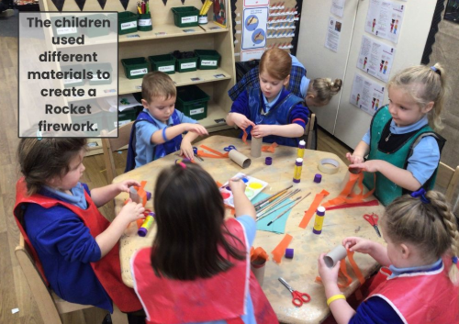  3D Form – Make a firework.  Christmas Crafty  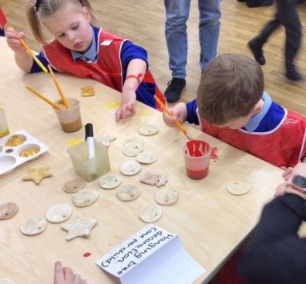  Activities Christmas, explore through dancing, songs ,art work, stories and role play.  Diwali  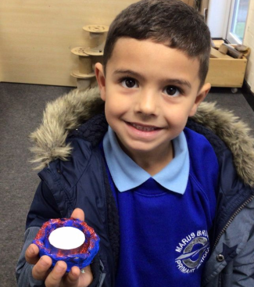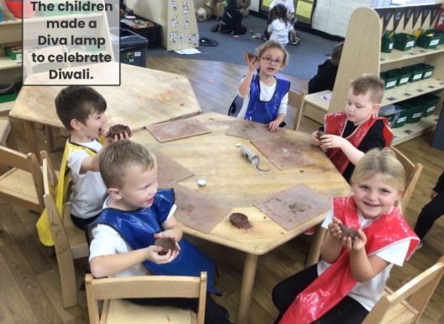  Form-Art related to Diwali, e.g. diva lamps rangoli patterns.  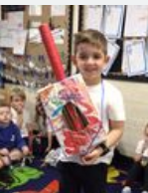  Children made musical instruments.  Remembrance Day  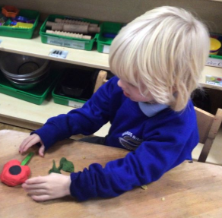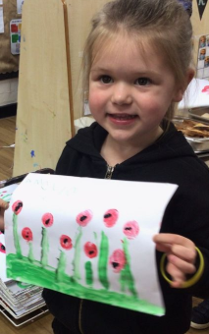  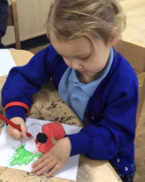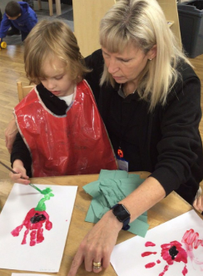  Painting – Use paints to paint poppies.  Chinese New Year  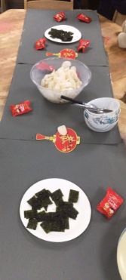  Activities Chinese New Year, explore through ,art work, stories and role play. Children write their name in Chinese and make lanterns.  Pancake Day  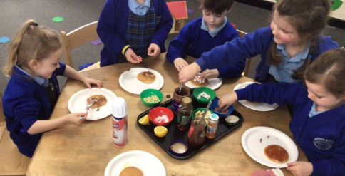  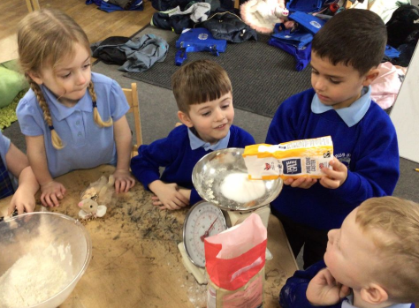  Food - Design and decorate pancakes.  Easter  Bridge Builder Bake and Serve food for guest  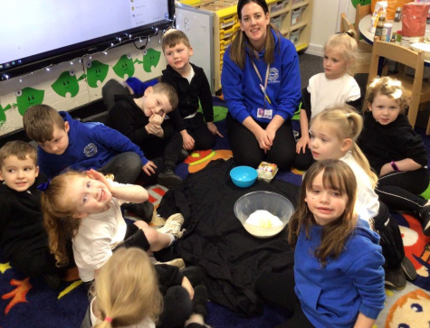  Printing with 3D shapes.  Building with 3D shapes.  Explore and experiment with different textures. Safely use and explore a variety of materials.  Food – Make Crispy Cakes for Easter Make an Easter Card. Sing Easter Songs.  Text: The Little Red Hen  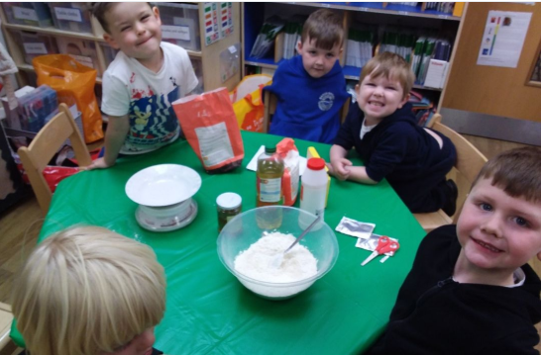  Making bread. We carefully measured out ingredients using scales, tablespoons and teaspoons. We kneaded the bread, baked and enjoyed!  Text: The 3 Little Pigs  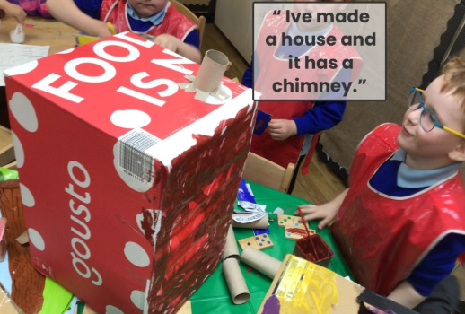  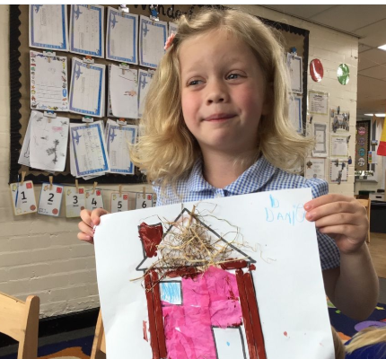  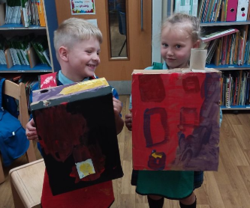  The children were challenged to make a strong house that the big bad wolf could not blow down.  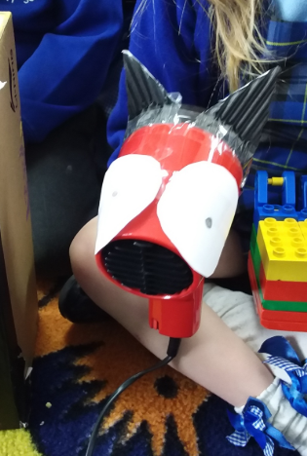  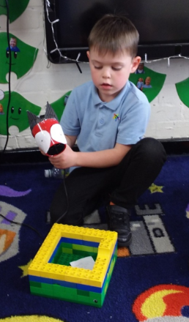  Earth Day  Children used recycled materials to design and make their own structures.  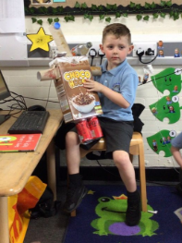  Eid  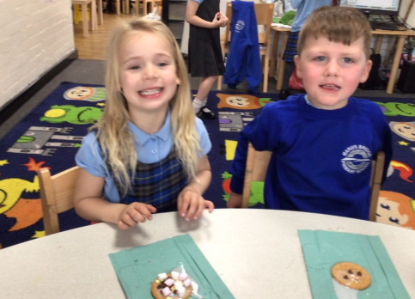  To celebrate Eid Al – Fatr, the end of Ramadan, we decorated biscuits for our feast.  Easter  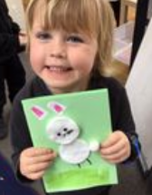  We made easter cards to send to our families.
Reception
Draw information from a simple map.
Explore the natural world around them.
End of EY Expectations – ELG for UTW
The Natural World
Explore the natural world around them, making observations and drawing pictures of animals and plants.
R.E

Links for R.E are found mainly in Personal Social & Emotional Development and Understanding the World
Reception  See themselves as a valuable individual.  Build constructive and respectful relationships.  Express their feelings and consider the feelings of others.  Think about the perspectives of others.  End of EY Expectations – ELG for PSED  Building Relationships  Form positive attachments to adults and friendships with peers.  Show sensitivity to their own and to others’ needs.  Managing Self  Explain the reasons for rules, know right from wrong and try to behave accordingly. | Links to our curriculum and literature spine:  Special Times  Say why festivals are special times for believers of different  Faiths.  Text: The Everywhere Bear  Special Places  Visit to the library.  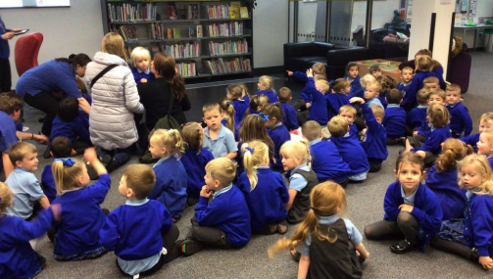  Text: The Avocado Baby  Special People  Talk about special people in my family. Bridge Builder – draw my family tree.  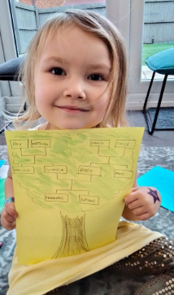  Text: The Colour Monster  Special People  Talk about feelings and emotions.  Text: Think Big  Have dreams and aspirations. What do I want to be when I grow up?  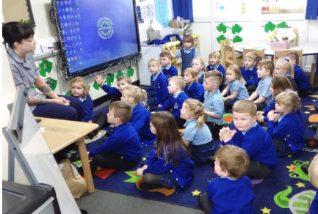  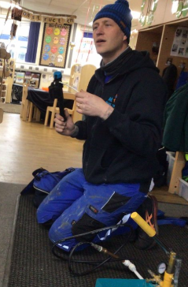  We had some parent visitors come into school to talk about their jobs.  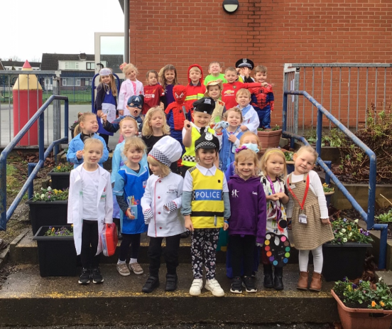  Children dressed up as what they want to be when they are grown up.  Text: The Queen’s Present  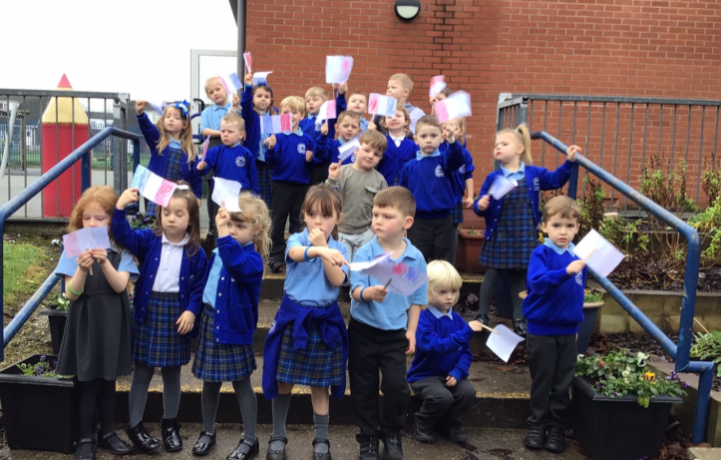  Text: The Great Race  Special Times  Recall simple stories connected with Christmas/Harvest/ Diwali and Eid.  Text: Somebody Swallowed Stanley  Special Places  Talk about ways in which people can harm the natural world  Talk about ways in which people can look after the natural world  Text: Jack and the Flum Flum Tree  Special People  Talk about special people in my family.  Special Times  Recall simple stories connected with Christmas/Harvest/ Diwali and Eid.  Diwali  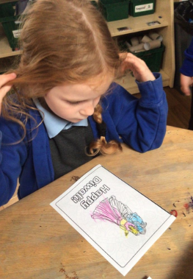  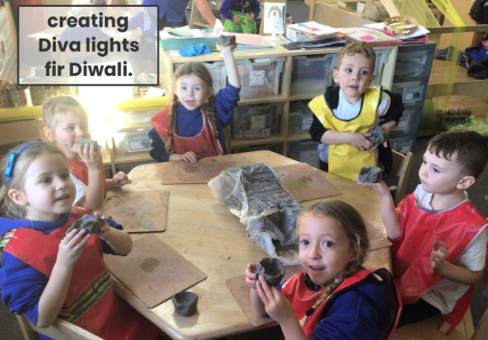  Text: The Queen’s Present  Christmas  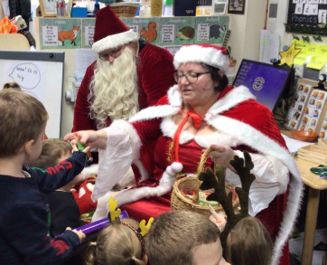  We had visit from Father Christmas and Mr Claus.  Chinese New Year  We read the story the Great Race. Dragon dancing and having a Chinese buffet.  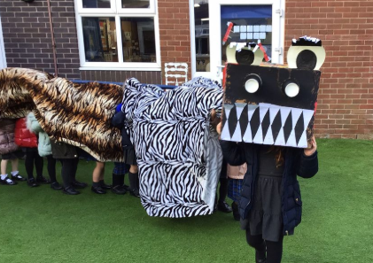  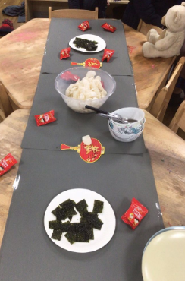  Pancake Day  We read the story Mr Wolf’s pancakes. The children decorated pancakes.  Easter  We read the story We are going on an egg hunt. We went on an Easter Egg hunt.  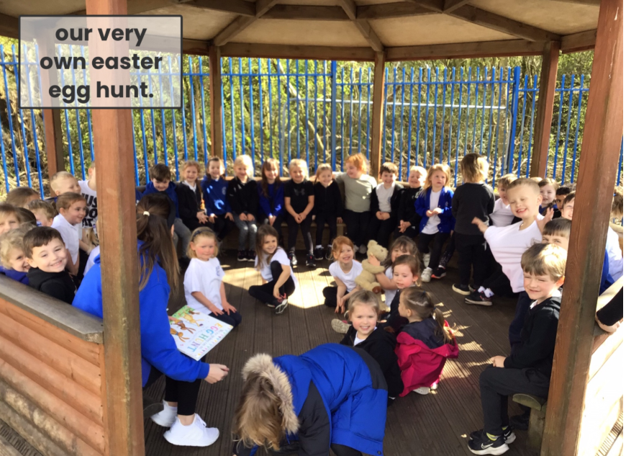  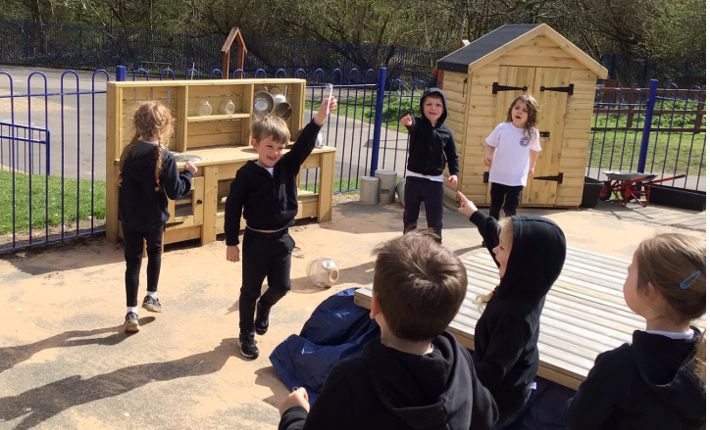  St George’s Day  We read the story all about St George and children completed activities such as making flags and crowns.  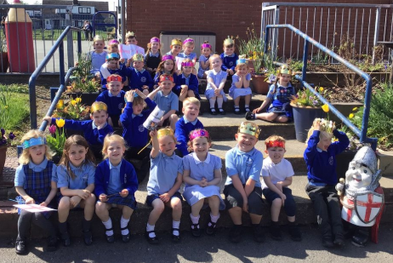  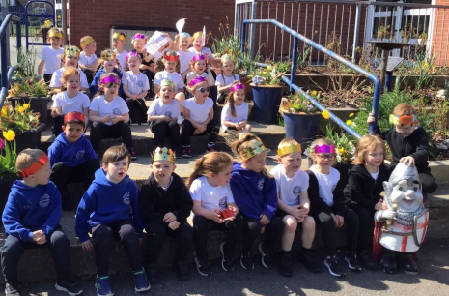  Eid  We watched the let’s celebrate cbeebies clips. Children decorated biscuits, coloured mendi hand patterns.  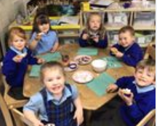  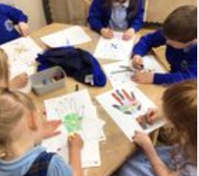  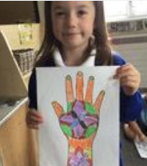  The Queen’s Birthday  The children made crowns and sang Happy Birthday to the queen.  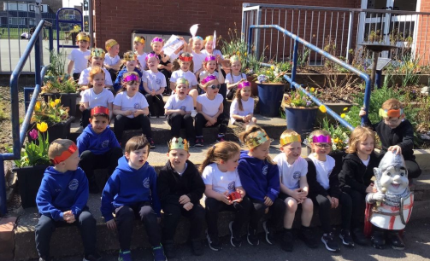  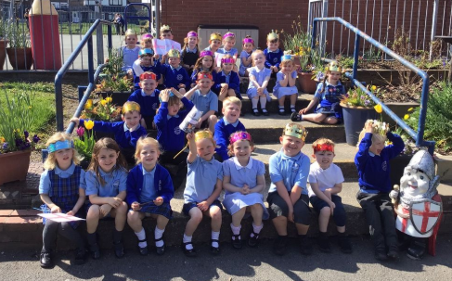  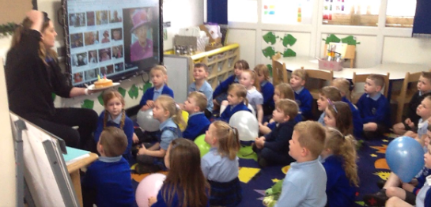  Queen’s Jubilee  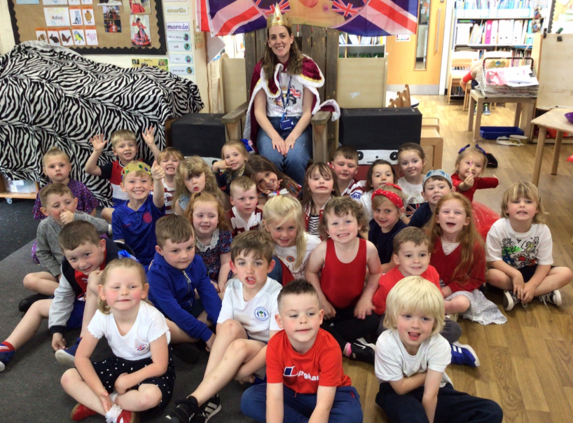  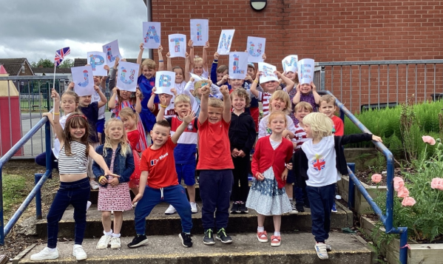  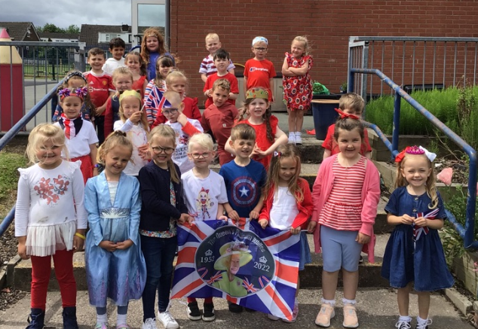  The children took part in their very own Royal Variety talent show. We had a tea party with our families.
UTW
Reception
Understand that some places are special to members of their community.
Recognise that people have different beliefs and celebrate special times in different ways.
End of EY Expectations – ELG for UTW
People Culture and Communities
Know some similarities and differences between different religious and cultural communities in this country, drawing on their experiences and what has been read in class.
Geography
Links for Geography are found mainly in Mathematics and Understanding the World
Mathematics  Reception  Select, rotate and manipulate shapes in order to develop spatial reasoning skills. | Links to our curriculum and literature spine:  Text: The Everywhere Bear  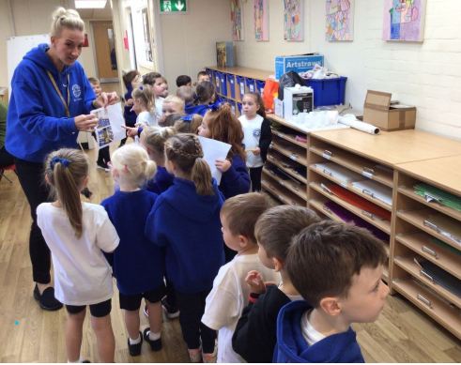  We went on a hunt to find the everywhere bear. We walked all around our new school.  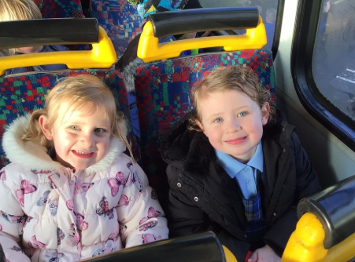  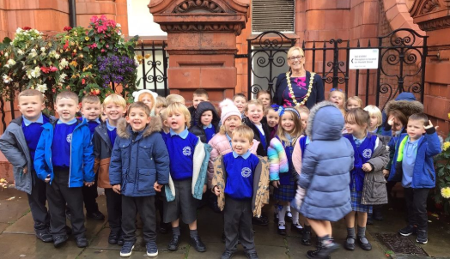  We went for a visit to Wigan Library.  Text: The Avocado Baby  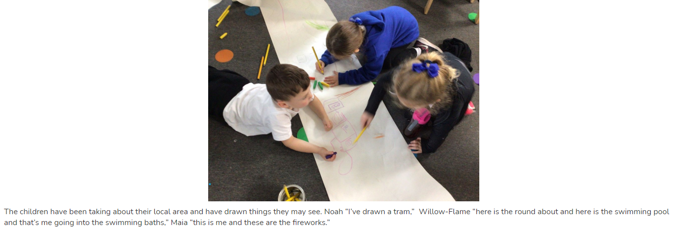  The children were talking about the local area and drew things they may see.  Text: Hovis the Hedgehog  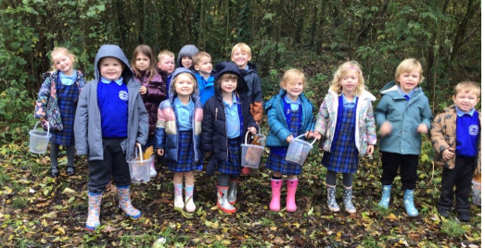  We went on an Autumn walk in the woods and collected things that had fallen from the trees.  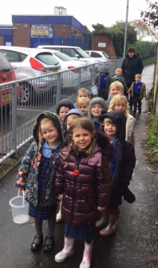  Text: Think Big  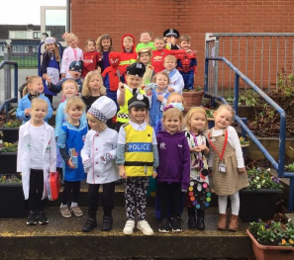  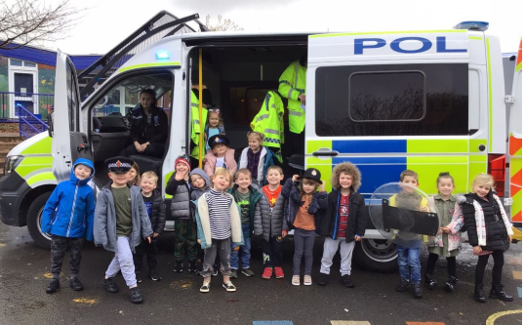  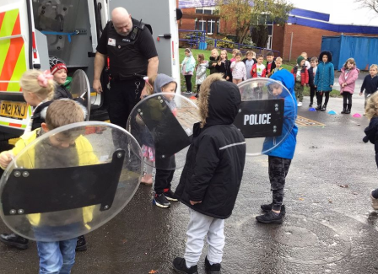  We had a visit from the police. They came to investigate what had happened to Humpy Dumpty.  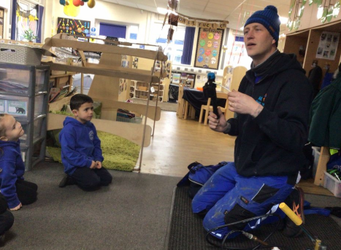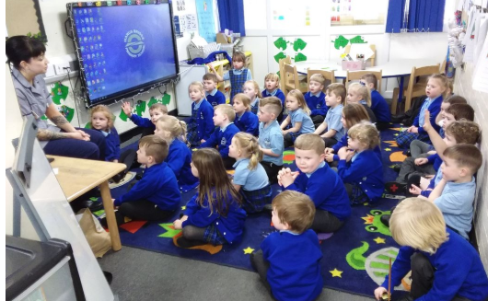  Some of our children’s parents came to talk about their jobs.  Text: The Queen’s Present  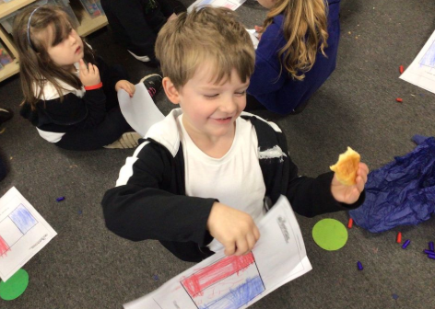  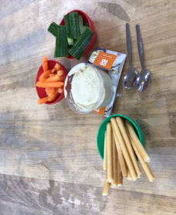  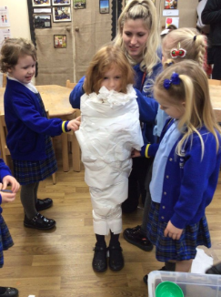  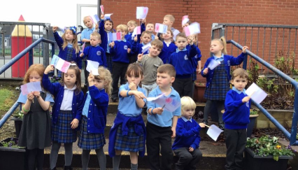  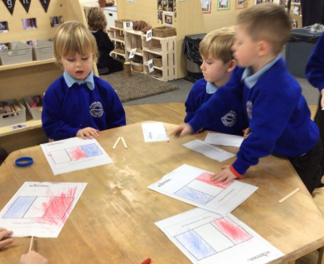  We coloured flags, talked about each county and tasted food from different countries around the world.  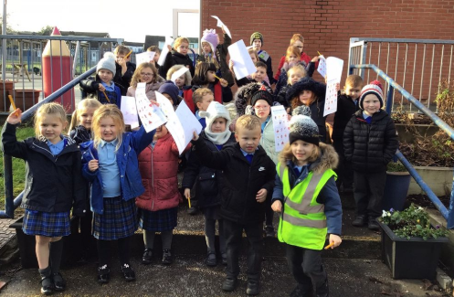  We went on a winter walk to spot signs of winter.  Text: Astro Girl  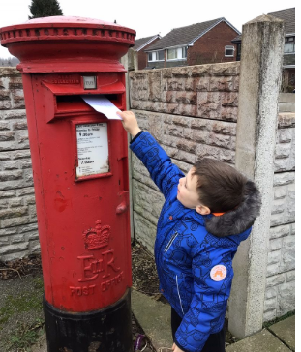  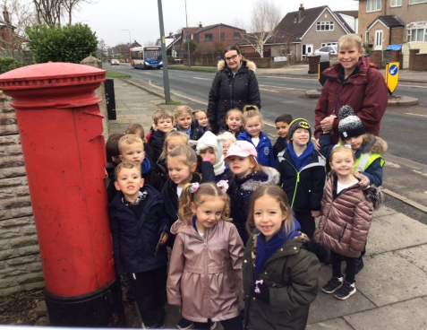  We wrote a letter to Astrid and had a walk to the local post box.  Text: The Three Little Pigs  We have been learning about our local environment. We looked at different styles of houses and made a graph to gather information.  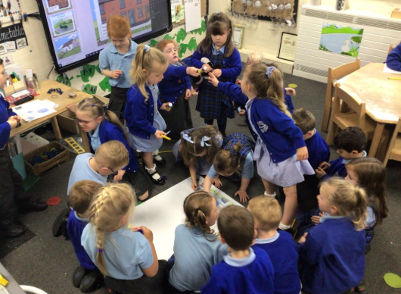  Earth Day  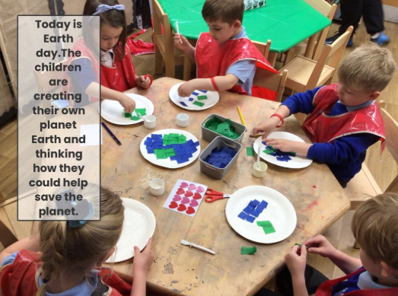  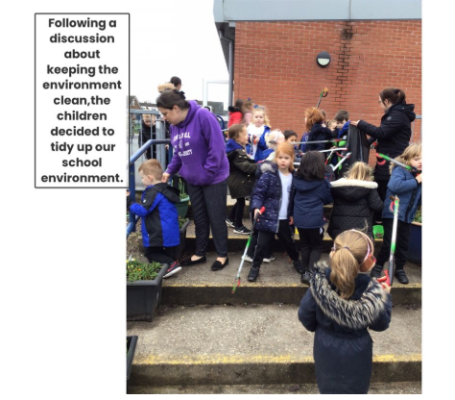  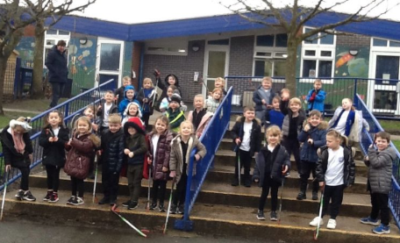  We went on a litter pick to keep our planet clean.
UTW
Reception
Draw information from a simple map.
Understand that some places are special to members of their community.
Recognise some similarities and differences between life in this country and life in other countries.
Recognise some environments that are different to the one in which they live.
Understand the effect of changing seasons on the natural world around them.
End of EY Expectations – ELG for UTW
People Culture and Communities
Describe their immediate environment using knowledge from observation, discussion, stories, non-fiction texts and maps.
Know some similarities and differences between different religious and cultural communities in this country, drawing on their experiences and what has been read in class.
Explain some similarities and differences between life in this country and life in other countries, drawing on knowledge from stories, non-fiction texts and – when appropriate – maps.
The Natural World
Explore the natural world around them, making observations and drawing pictures of animals and plants.
Know some similarities and differences between the natural world around them and contrasting environments, drawing on their experiences and what has been read in class.
Understand some important processes and changes in the natural world around them, including the seasons and changing states of matter

History
Links for History are found mainly in Understanding the World, Mathematics and Communication & Language
Reception  Comment on images of familiar situations in the past.  Compare and contrast characters from stories, including figures from the past.  End of EY Expectations – ELG for UTW  Past and Present  Talk about the lives of the people around them and their roles in society.  Know some similarities and differences between things in the past and now, drawing on their experiences and what has been read in class.  Understand the past through settings, characters and events encountered in books read in class and storytelling. | Links to our curriculum and literature spine:  Text: The Avocado Baby  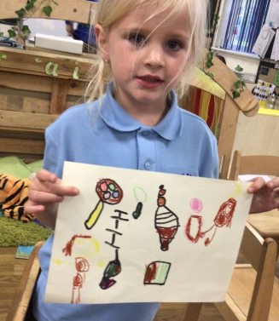  We talked about and drew what a baby needs.  Text: Jack and the Flum Flum Tree.  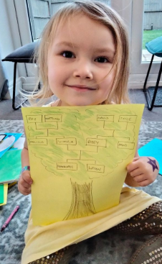  Bridge Builder: The children made their own family trees.  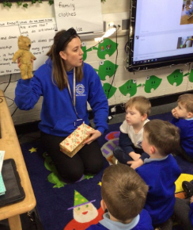  We talked about what toys we wanted for Christmas and looked at toys from the past and how they were the same and different. We watched a video of Mrs Miller opening her Christmas present when she was 5 years old.  Remembrance Day  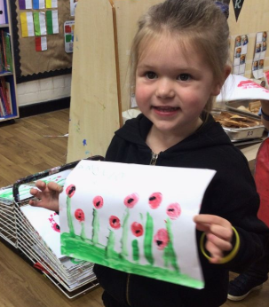  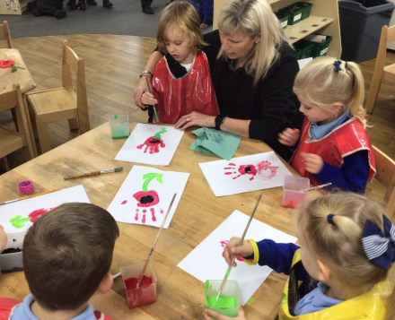  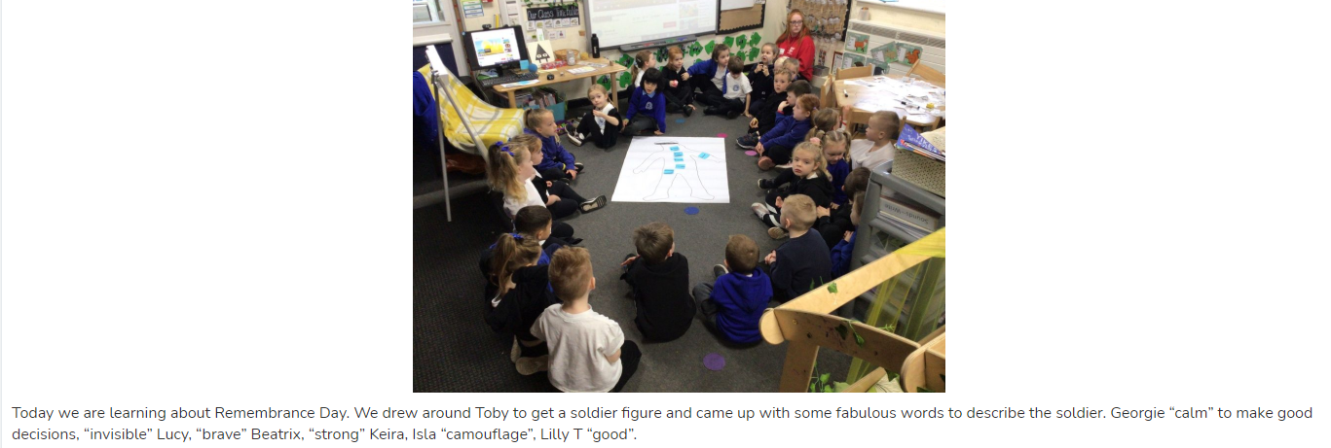  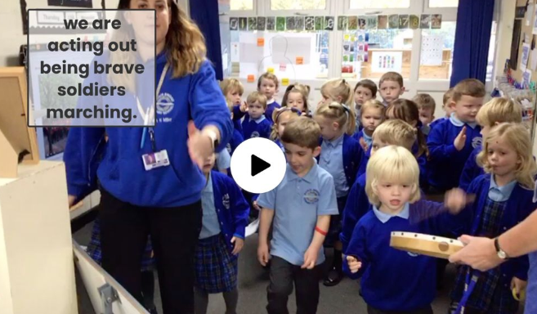  We celebrated Remembrance Day. We marched like soldiers, painted poppies and talked about what a solider has to have.
Communication & Language
Reception
Connect one idea or action to another using a range of connectives.
End of EY Expectations – ELG for Speaking
Speaking
Express their ideas and feelings about their experiences using full sentences, including use of past, present and future tenses and making use of conjunctions, with modelling and support from their teacher.
Science
Links for Science are found mainly in Expressive Arts & Design and Understanding the World
EAD  Reception  Return to and build on their previous learning, refining ideas and developing their ability to represent them: PLAN DO REVIEW APPROACH.  Create collaboratively sharing ideas, resources and skills.  End of EY Expectations – ELG for EAD  Creating with Materials  Safely use and explore a variety of materials, tools and techniques, experimenting with colour, design, texture, form and function. | Links to our curriculum and literature spine:  Text: The Room on the Broom  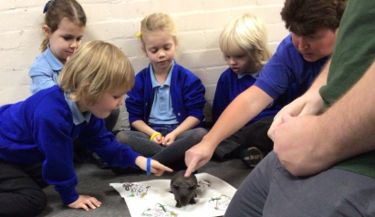  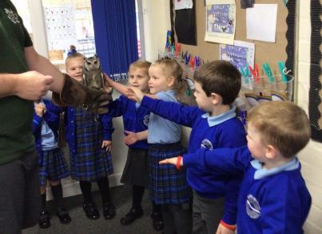  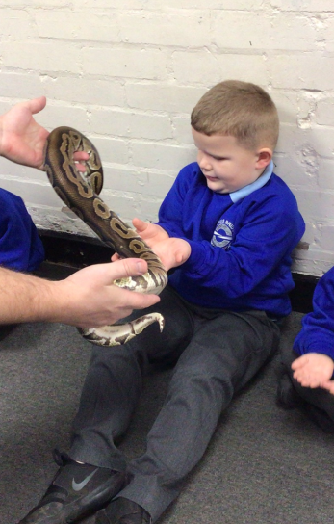  We had a visit from Dan the Critter Man.  Text: Think Big  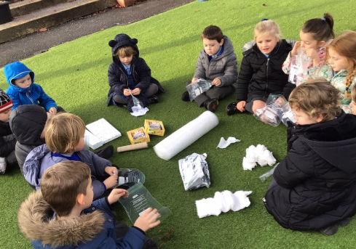  We did an experiment to see if we could use different materials to protect a raw egg and hard boiled egg.  Text: The Queen’s Present  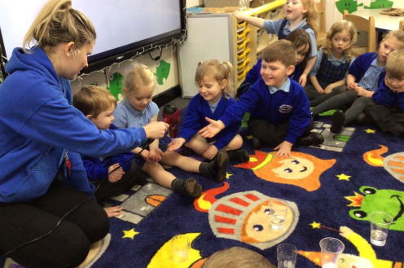  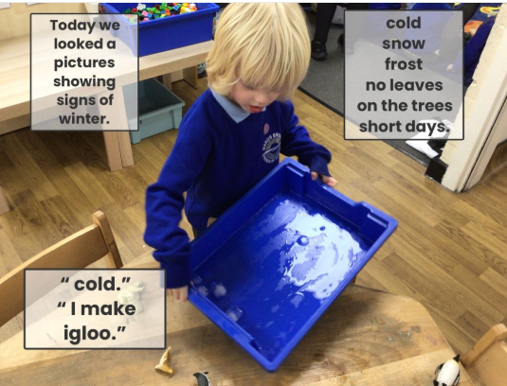  We looked at ice melting and talked about how we could speed up the process.  Winter Walk  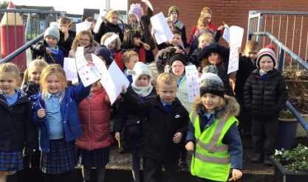  We went on a winter walk to spot signs of winter.  Text: Astro Girl  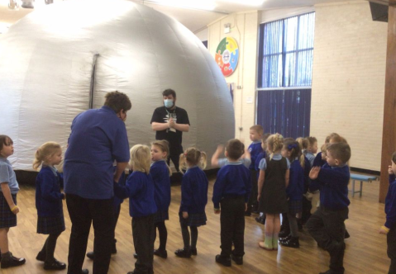  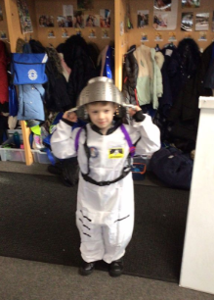  We had a visit from the Wonder Dome.  Text: Somebody Swallowed Stanley  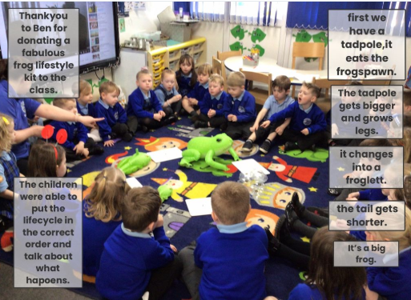  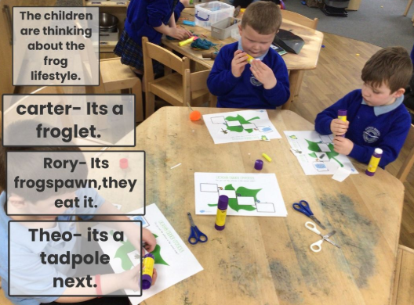  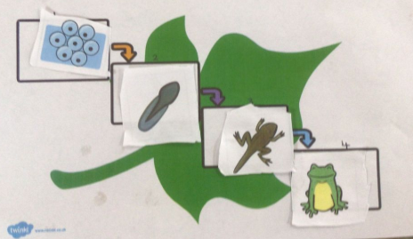  We talked about lifecycles.  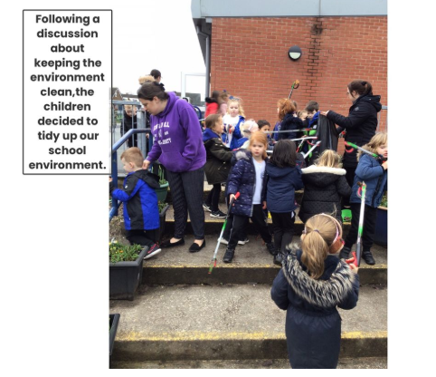  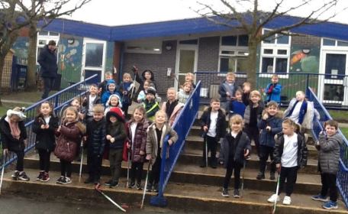  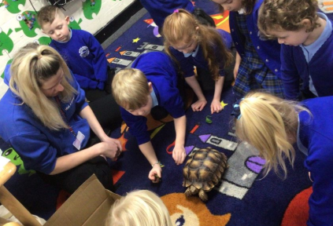  We had a visit from a tortoise and looked and the similarities and differences between a turtle and a tortoise.  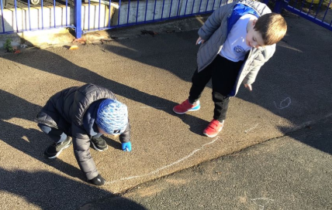  We drew round each other’s shadows.  Text: Jack and the Flum Flum Tree  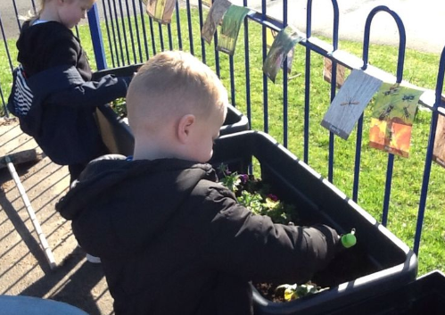  We looked a plants and cared for them.  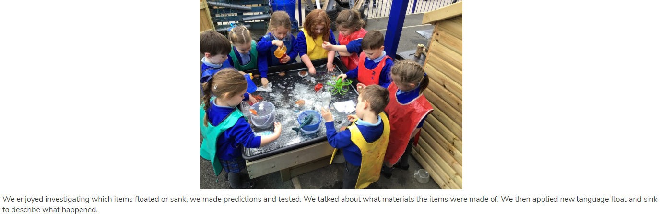  We made out own boats out of different materials thinking about which material was best.  National Bird Watching Week  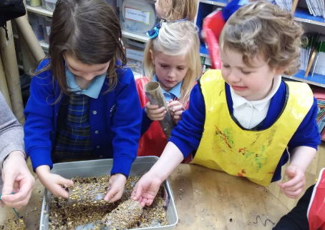  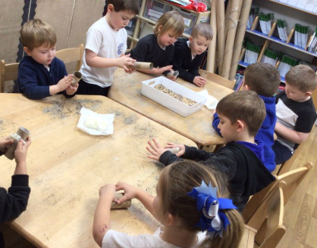  We made bird feeders.  The Three Little Pigs  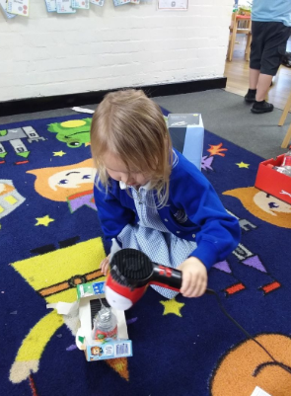  The children were challenged to make a strong house that the big bad wolf could not blow down.  The Ugly Duckling  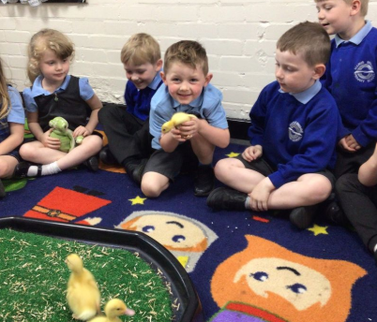  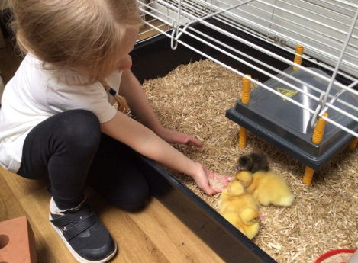  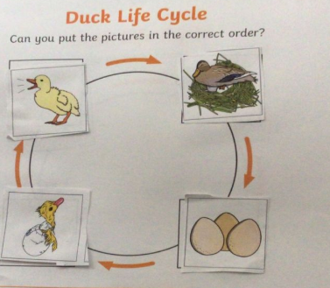  We had ducklings come to stay with us for 10 days. We watched the eggs hatch and cared for them exploring their life cycle.
UTW
Reception
Explore the natural world around them.
Describe what they see, hear and feel whilst outside.
Recognise some environments that are different to the one in which they live.
Understand the effect of changing seasons on the natural world around them.
End of EY Expectations – ELG for UTW
The Natural World
Explore the natural world around them, making observations and drawing pictures of animals and plants.
Know some similarities and differences between the natural world around them and contrasting environments, drawing on their experiences and what has been read in class.
Understand some important processes and changes in the natural world around them, including the seasons and changing states of matter.
Music
Links for Music are found mainly in Expressive Arts & Design, Physical Development and Communication & Language
EAD  Reception  Listen attentively, move to and talk about music, expressing their feelings and responses.  Sing in a group or on their own, increasingly matching the pitch and following the melody.  Explore and engage in music making and dance, performing solo or in groups.  End of EY Expectations – ELG for EAD  Being Imaginative and Expressive  Sing a range of well-known nursery rhymes and songs.  Perform songs, rhymes, poems and stories with others, and – when appropriate try to move in time with music. | Links to our curriculum and literature spine:  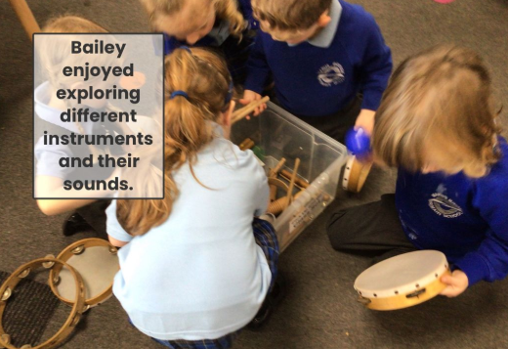  We play instruments during every music lesson.  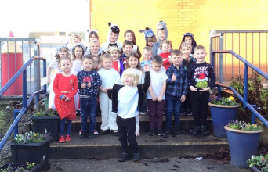  Christmas music and songs – We performed a Nativity.  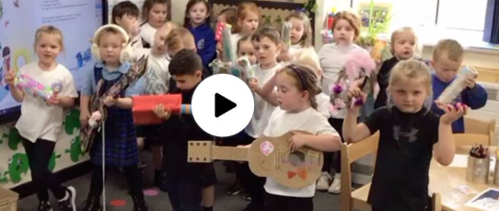  Make an instrument. Play music to distract the monkey.  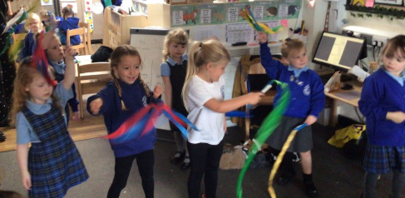  Activities Chinese New Year, explore through dancing, songs, art work, stories and role play.  Three Little Pigs  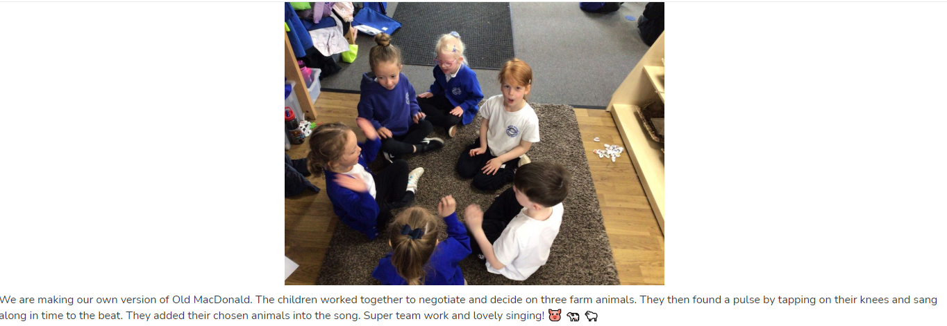  We made our own version up of the song Old McDonald. We tapped on our knees to find the beat.  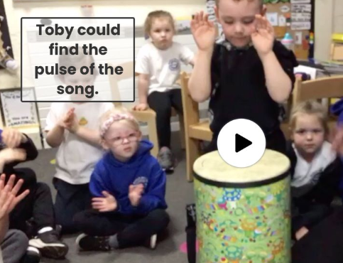  We use a drum in lessons to find the pulse.  We performed our very own Royal Varity show in which children danced, sung songs and performed in front of the class.  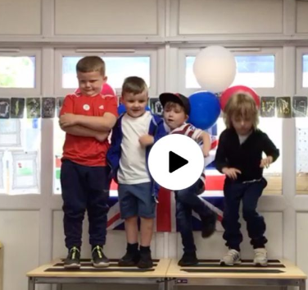
Physical Development
Reception
Progress towards a more fluent style of moving, with developing control and grace.
Develop the overall body strength, co-ordination, balance and agility needed to engage successfully with future physical education sessions and other physical disciplines including dance, gymnastics, sport and swimming.
End of EY Expectations – ELG for PD
Move energetically, such as running, jumping, dancing, hopping, skipping and climbing.

Communication & Language
Reception
Listen carefully to rhymes and songs, paying attention to how they sound.
Learn rhymes, poems and songs.
End of EY Expectations – ELG for CL
Offer explanations for why things might happen, making use of recently introduced vocabulary from stories, non-fiction, rhymes and poems when appropriate.
Physical Education

From sticking out their tongues to sitting up on their own, our youngest children at The Acorns are supported to develop the physical skills needed for their future learning. Physical development includes both gross (large muscle movements) and fine (small movements) motor skills that contribute to overall physical development. Physical development experiences and activities are crucial in our early years curriculum and are cited as one of the three prime areas of learning and development in the Early Years Statutory Framework (EYFS).

The benefits of physical activity in the emotional domain are well understood, and energetic running and chasing activities outdoors are positive methods to regulate emotions. Equally important, but more nuanced are: creative painting, moulding and manipulating activities, not only help to refine hand-eye co-ordination, accuracy, spatial understanding, two-handed co-ordination and fine motor skills, but also provide our young children with physical opportunities to express and work through their emotions.

Physical development is present in all aspects of EY. However, in this document, the following links are highlighted in: Expressive Arts & Design, Physical Development, Mathematics and Communication & Language.

Physical Development  Reception  Revise and refine the fundamental movement skills they have already acquired: - rolling – crawling – walking – jumping – running – hopping – skipping – climbing  Progress towards a more fluent style of moving, with developing control and grace.  Develop the overall body strength, co-ordination, balance and agility needed to engage successfully with future physical education sessions and other physical disciplines including dance, gymnastics, sport and swimming.  Combine different movements with ease and fluency.  Confidently and safely use a range of large and small apparatus indoors and outside, alone and in a group.  Develop overall body-strength, balance, co-ordination and agility  Further develop and refine a range of ball skills including: throwing, catching, kicking, passing, batting, and aiming.  Develop confidence, competence, precision and accuracy when engaging in activities that involve a ball.  Know and talk about the different factors that support their overall health and wellbeing: - regular physical activity – healthy eating – toothbrushing – sensible amounts of ‘screen time’ – having a good sleep routine – being a safe pedestrian  End of EY Expectations – ELG for PD  Gross Motor Skills  Negotiate space and obstacles safely, with consideration for themselves and others.  Demonstrate strength, balance and coordination when playing.  Move energetically, such as running, jumping, dancing, hopping, skipping and climbing. | 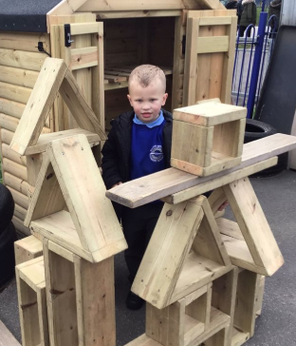  We have a large construction are outdoors that the children can play with independently.  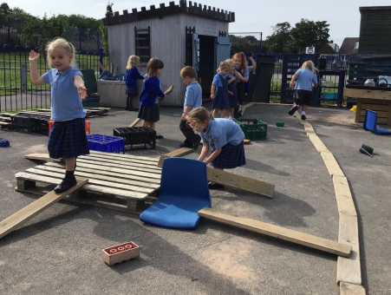  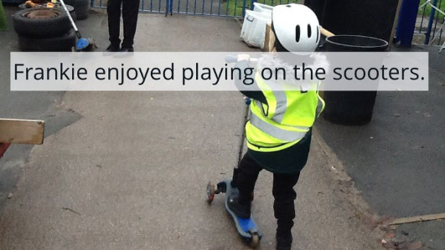  We used scooters and bikes in our outdoor area.  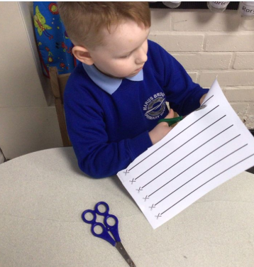  We use fine motor skills weekly including scissor skills.  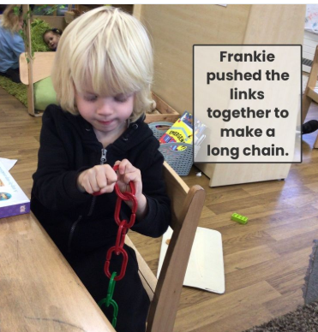  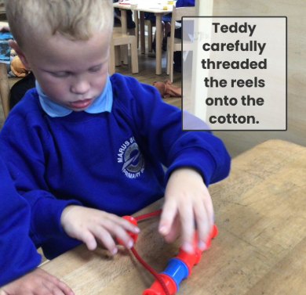  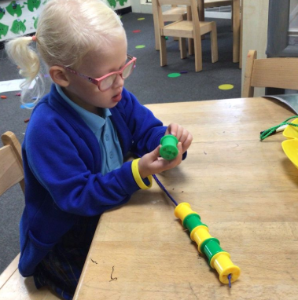  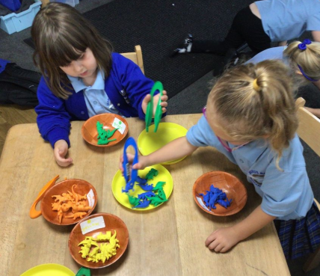  We have a funky fingers challenge are in our classroom where weekly challenges are set to work on fine motor skills. Including threading, picking objects up with tweezers, linking items together.  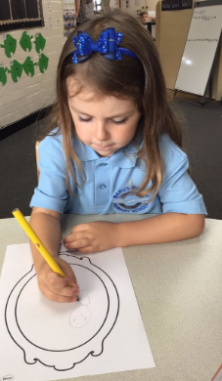  We encourage children to use the correct pencil grip age appropriate and trach pencil grip using a class tracker.  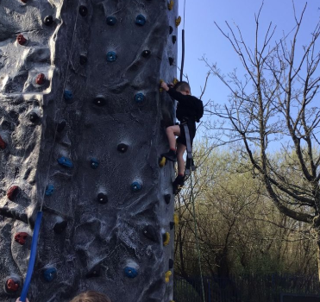  During helahty living week children were challenge to climb the climbing wall.  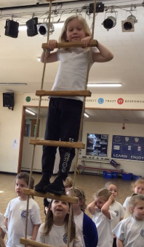  Jack and the Flum Flum Tree  We climbed the ropes in the hall.
Mathematics
Reception
Select, rotate and manipulate shapes in order to develop spatial reasoning skills.
Compose and decompose shapes so that children recognise a shape can have other shapes within it, just as numbers can.
EAD
Reception
Listen attentively, move to and talk about music, expressing their feelings and responses.
Watch and talk about dance and performance art, expressing their feelings and responses.
Explore and engage in music making and dance, performing solo or in groups.
End of EY Expectations – ELG for EAD
Being Imaginative and Expressive
Perform songs, rhymes, poems and stories with others, and – when appropriate try to move in time with music.
English within EYFS
Please refer to the newly updated Key Specification document

Mathematics within EYFS
Please refer to the newly updated Key Specification document

Please note, we will not have physical evidence for all objectives. This is in line with new guidance:
“Assessments should not entail prolonged breaks from interaction with children, nor require excessive paperwork,”
“Practitioners draw on their knowledge of the child and their own expert professional judgement and should not be required to prove this through collection of physical evidence.”
(Statutory Framework for the EYFS 2021.)

Spanish:

