Curriculum Policy
Written by: Claire Boffey
Effective from September 2022
Date of review: September 2024
Subject Coordinator 22/23
Mathematics
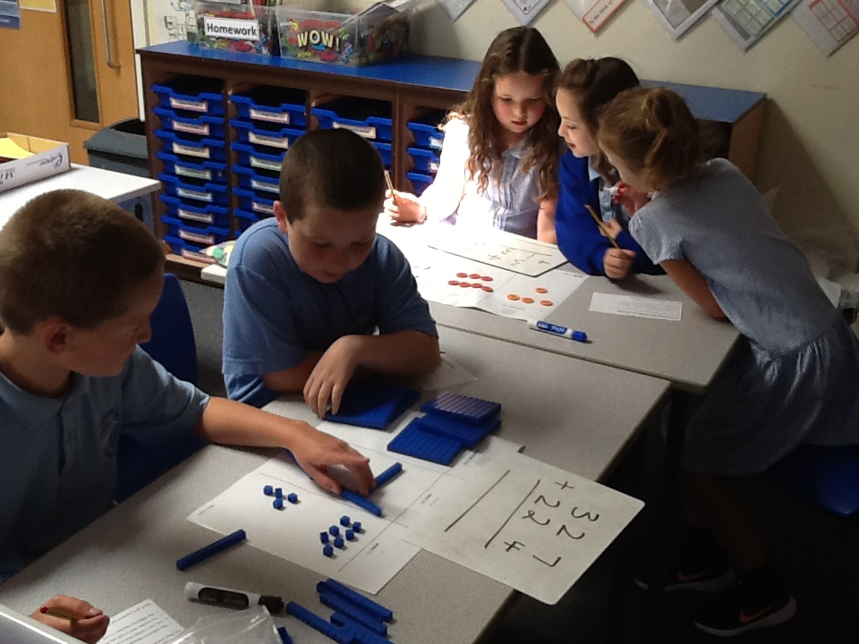
Mathematics Policy
What is our vision?
All children develop a sound understanding of all areas of Mathematics, through fun, enjoyable and interactive lessons. All pupils are encouraged to become independent and motivated mathematicians. Our progressive curriculum enables pupils to scaffold, support and challenge their own learning equipping them with valuable numeric, reasoning and problem-solving skills for life.
Curriculum Aims:
Early Years
Maths Educational Programme
Mathematics Developing a strong grounding in number is essential so that all children develop the necessary building blocks to excel mathematically. Children should be able to count confidently, develop a deep understanding of the numbers to 10, the relationships between them and the patterns within those numbers. By providing frequent and varied opportunities to build and apply this understanding - such as using manipulatives, including small pebbles and tens frames for organising counting - children will develop a secure base of knowledge and vocabulary from which mastery of mathematics is built. In addition, it is important that the curriculum includes rich opportunities for children to develop their spatial reasoning skills across all areas of mathematics including shape, space and measures. It is important that children develop positive attitudes and interests in mathematics, look for patterns and relationships, spot connections, ‘have a go’, talk to adults and peers about what they notice and not be afraid to make mistakes.
The overarching aim of the Mathematics National Curriculum is to provide children with a high-quality mathematics education therefore providing a foundation for understanding the world, the ability to reason mathematically, an appreciation of the beauty and power of mathematics, and a sense of enjoyment and curiosity about the subject.
We aim to develop a numerate environment where mathematical risk-taking, creativity and logical thought are encouraged in order to develop independent learners.
To achieve this the aims of teaching mathematics in our school are to ensure all children:
- become fluent in the fundamentals of mathematics by instilling confidence, fluency and mastery of key number facts and in the number system through varied and frequent practise
- develop a capacity to solve problems through decision making and reasoning in a range of contexts
- develop a practical understanding of the ways in which information is gathered, presented and interpreted
- explore features of shape and space and develop measuring skills to equip them with life skills
- develop mathematical communication through speaking and listening, practical activities and recording work

How do we achieve this?
In Early Years Foundation Stage, children are given the opportunity to develop their understanding of number and pattern through a combination of short, formal teaching as well as a range of planned structured play situations where there is plenty of scope for exploration.
Through KS1 and KS2, Children’s fluency in arithmetic remains of great importance, with number facts, times table facts and various strategies for calculation taught and practiced at school during mental maths lessons and with support sought from parents through homework activities.
Daily counting (forwards and backwards in many different sized steps as well as from different starting and ending points is essential) and mental strategies should be taught and practised in morning tasks and in the two mental maths lessons each week.
Prior learning should be completed and assessed before a new topic/concept is taught to inform planning for groups and individual children. White Rose Maths Scheme of Learning and small steps should be followed alongside the school's Mental to Written Calculation Policy and Mental Strategy Key Skills document to ensure progressions of efficient written calculation is developed and applied consistently in each year-group.
Concrete/Pictorial/Abstract teaching and learning should be implemented in every classroom. Children should be active from on outset of the lesson practising skills they haven't yet mastered (recapping on targets/correcting errors or challenge in Daily Review Task) moving on to new learning or applying learning in different contexts. They should be working at a good pace and encouraged to communicate their understanding of maths.
When teaching problem solving and reasoning skills across the curriculum, time (and sometimes whole lessons) should be given to each aspect of problem solving and reasoning ensuring children get thorough practise at: ‘preparing for problem solving’, ‘thinking through problems to establish what they know and don’t know so far’, ‘reasoning about their answer’; actually ‘doing the problem solving/reasoning’ effectively to then be able to ‘communicate the answer effectively’. They should evaluate the process.
Working Walls are used to support the children's learning.
Cross Curricular Mathematics – All strands can be supported using cross-curricular links to topic work (especially Statistics and Problem Solving). Teachers should identify cross-curricular work on medium term planning documents. World Maths Days will be used when appropriate for immersion and wider opportunities.
At Marus Bridge we recognise that parents make a significant difference to children's progress in Mathematics and encourage this partnership. The homework policy will offer further guidance to weekly homework. Children are encouraged to use Ten Town (EYFS), Numbots (KS1) and Times Tables Rockstars (KS2) at home as well as other online maths games and are rewarded with certificates in assemblies.

Scheme of Work:
Teachers use the planning structure and overviews from First4Maths alongside the Mental to Written Calculation Policy and Mental Strategy Key Skills document supported by resources outlined below.
Resources:
Maths Resources on the staff shared server/available:
- White Rose Resources
- Calculation policies
- Mental Calculation policy
- Number facts
- Assertive Mentoring
- Fluent in Five
- I see Reasoning
- Number games/maths songs/maths videos
- Maths vocabulary and definitions
Other resources:
- Practical resources are found in classrooms. Larger resources and games are found in the cupboard opposite the Year 5 classrooms.
- White Rose Maths resources (https://resources.whiterosemaths.com/ - see Claire Boffey for log on details)
- CGP Workbooks - one in each classroom for that year group.
- Classroom Secrets (https://classroomsecrets.co.uk/ - see Claire Boffey for log on details)
- Ten Town/Numbots/Times Tables Rockstars (see Claire Boffey for log on details)
- PiXL website (https://www.pixl.org.uk/ – see Suzanne Carver for log in details)
- Testbase (see Claire Boffey for log on details)

Assessment – How do we assess skills and understanding?
Early Years
In Reception, children are assessed against the Early Learning Goals for ‘Mathematics’.
The ELGs are based on typical child development at the age of 5, so most children are likely to meet the ‘expected’ level of development. Teachers should use their professional knowledge of the child to decide whether each ELG description best fits the child’s learning and development.
Mathematics
ELG: Number
- Have a deep understanding of number to 10, including the composition of each number.
- Subitise (recognise quantities without counting) up to 5.
- Automatically recall (without reference to rhymes, counting or other aids) number bonds up to 5 (including subtraction facts) and some number bonds to 10, including double facts.
ELG: Numerical Patterns
- Verbally count beyond 20, recognising the pattern of the counting system.
- Compare quantities up to 10 in different contexts, recognising when one quantity is greater than, less than or the same as the other quantity.
- Explore and represent patterns within numbers up to 10, including evens and odds, double facts and how quantities can be distributed equally.

Formative assessment:
- Teachers use a short prior learning assessment before each unit of work to inform planning and use pre-teaching if required.
- Teachers use daily formative assessment to inform lesson planning and necessary differentiation. Pupils’ work is marked in line with the school Feedback Policy, modelling how corrections are made and giving children a chance to learn from their misconceptions or incorrect methods – this may occur during daily review time or at point of need.
- Mental maths sessions twice weekly following Key Skills document
- Times-Table Challenge - Times Table Rockstars certificates to be awarded in assembly, alongside white, red and blue times tables bands to celebrate children knowing their times tables. (White - 2,5,10, Red - 3,4,8, Blue - 6,7,9,11,12) Children should be tested on a regular basis by the class teacher on their times tables knowledge.
- Ten Town and Numbots challenges set and tracked by teachers in EYFS and KS1.
- Weekly homework will be used as an assessment tool to assess whether children have understood the weekly work in school and can complete it independent at home.
Summative assessment:
- In Reception, children are assessed against the Early Learning Goals for Mathematics that forms part of the Foundation Stage Profile.
- From Year 1 - 6 Teachers use PiXL assessments for arithmetic, reasoning and problem solving termly. These are marked by teachers and analysed to inform teaching and interventions. Teachers can use PiXL resources to support teaching gaps noted during marking of assessments.
Teachers allocate a PiXL grade to children based on their performance in assessments and in class. (See Appendix 1.) These are entered onto the school’s tracking spreadsheets.
- Year 6 to use previous years SAT papers to track progress.
- Number fact assessment takes place at key points four times per year.
Health and Safety
When using practical resources ensure all children use them safely and they are carefully tidied up afterwards. Younger children should be monitored by an adult if the teacher feels it is necessary when working with small objects.

Inclusion and Safeguarding Considerations
The class teacher meets the needs of the Most Able and SEN by adapting Mathematic lessons through levels of support provided and adopting a mastery approach in activities given. Children identified as having additional Special Educational Needs may need greater adaptation of materials and tasks consistent with that child’s I.E.P. (Individual Education Plan). Where appropriate, the B-Squared small steps should be used to support planning closely linked to the child’s needs. The class teacher should identify those children who may be gifted in Mathematics and provide them with appropriate learning opportunities to stretch and challenge their learning. All children will be given opportunities to participate on equal terms in all Mathematics activities and due consideration will be given to the principles of Inclusion.
Other Points/Considerations:
If additional intervention is required outside of school hours this needs to be discussed with subject lead, phase leader and SLT prior to it taking place. Timetabling of intervention during the school day needs to be agreed with all year groups.
Monitoring and Review:
Mathematics is monitored by the subject lead, who provides regular support and feedback to colleagues. Monitoring includes lesson drop ins, reviews of working walls, environment walks and book scrutiny.
Internal observations will take place annually by phase lead/SLT/subject lead to monitor teaching and learning.
Internal moderation of books will take place annually. Year 2 and Year 6 external moderation with other schools to be considered if felt necessary.
Internal moderation and support is provided by the external company ‘First4Maths’ at key points in the year assessing against Assessment Tags.

Appendix 1 – PiXL Language of Assessment
PiXL Grades | Definition
A1 | Based on current rate of progress, will secure Above Expected Standard
E1 | Based on current rate of progress, will secure Expected Standard
B1 | Based on current rate of progress, will not achieve Expected Standard but with the right forensic support and targeted intervention, has the potential to do so.
B2 | Not expected to achieve Expected Standard

